Objective Questions

1.List the different dtypes of columns in table “ball_by_ball” (using information schema)

Ans The “ball_by_ball” table consists of 11 columns; each defined with the integer data type.

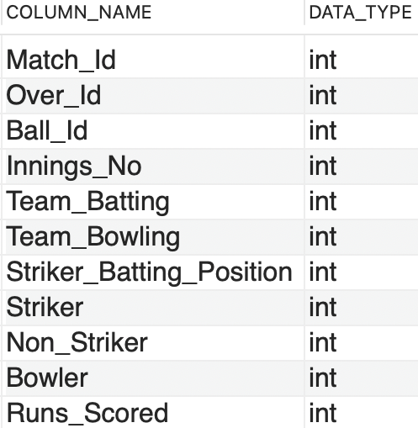

Query:

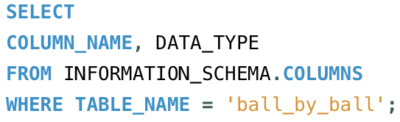

2. What is the total number of runs scored in 1st season by RCB (bonus: also include the extra runs using the extra runs table)

Ans. To find the total runs scored by Royal Challengers Bangalore (RCB) in the first IPL season, including extra runs, the following tables are needed:

**Required Tables:**

* matches: Contains match details, including the teams and season. team: Provides team names and IDs.
* ball_by_ball: Tracks each ball bowled, including the team batting.
* extra_runs: Tracks additional runs like wides and no-balls.

**Query Approach:**

* Match Selection: Filters matches where RCB played (Team_Id = 2) in the first season.
* Joining Tables: Joins relevant tables to link matches, balls, runs scored, and extra runs.
* Sum Runs: Adds up runs scored by RCB's batsmen and any extra runs.

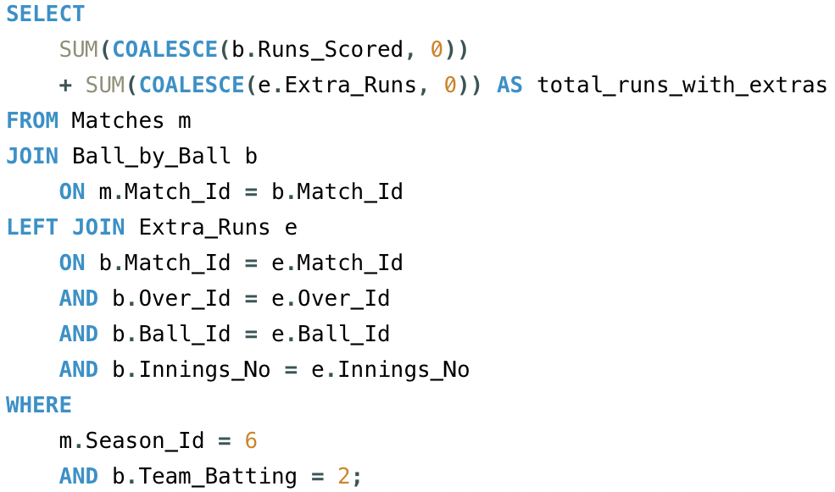

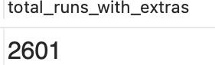

3.How many players were more than the age of 25 during season 2014?

**Tables Required:**

* **player** - To get the player's date of birth.
* **player_match** - To find which players participated in matches during season 2014.
* **matches** - To find matches in season 2014.
* **season** - To identify season 2014 and its matches.

**Query Approach:** This query calculates the number of unique players whose age was above 25 during the 2014 season. To achieve this:

* Join the player, player_match, and matches and season tables: This allows access to the player's date of birth and season year.
* Filter by season: The matches table is restricted to only those that belong to the 2014 season
* Age Calculation: The TIMESTAMPDIFF function computes the player's age at the time of each match. Only records where the player's age exceeds 25 on the date ‘2014-01-01’ are considered.
* Count Unique Players: The query counts distinct player IDs who meet the criteria above, giving the total number of players above 25 years of age during the 2014 season.

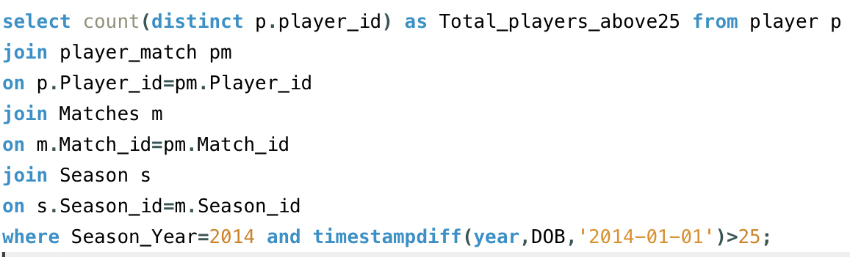

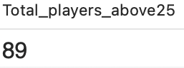

4. How many matches did RCB win in 2013?

**Tables Required**

* Matches – To get matches with match_winner and season_id
* Team – To get team_id of RCB
* Season – to filter season_year 2013.

**Query Approach:**

* Join the table matches and season with season_id
* Filter with season_year 2013 and to get the team RCB team id done the filter of match_winner using the subquery from the team table to get the RCB id.
* And lastly in the Select clause count the records to get the count of matches RCB won.

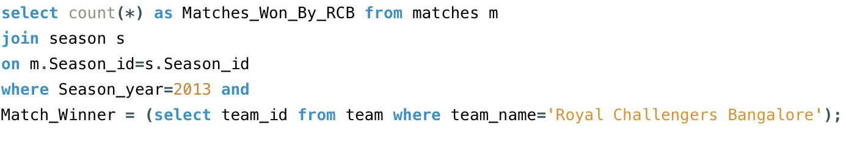

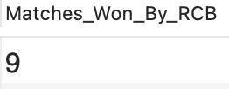

5. List the top 10 players according to their strike rate in the last 4 seasons

**Tables Required:**

* **Player –** To get player name
* **Matches –** To get the matched of last four season
* **Season –** To get the last four season
* **Ball_by_ball –** Contains run_scored and striker(player_id)

**Query Approach:**

* Identify last 4 seasons
* Filter relevant matches
* Use ball_by_ball table to collect balls faced and runs scored for each player in the filtered matches.
* Calculate strike rate using the formula

**Strike Rate=(Total Balls Faced/Total Runs Scored)×100**

* Sort the result by strike rate in descending order and limit the output to top 10 players.

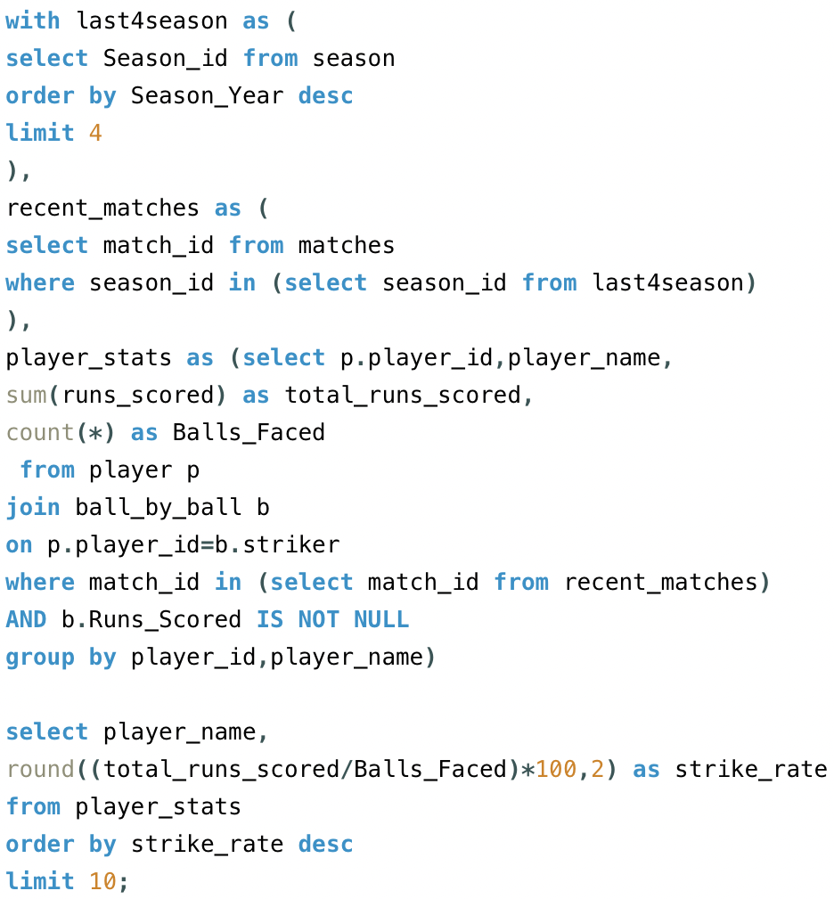

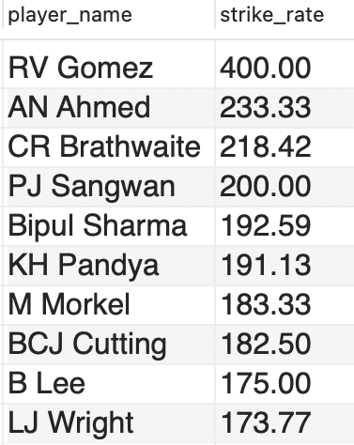

6. What are the average runs scored by each batsman considering all the seasons?

**Table Required:**

* **Ball_by_ball –** To calculate total runs scored by each player and to count total innings played.
* **Player –** To get player details such as player name and id.

**Query Approach:**

* Group the data in the Ball_by_Ball table by player (Striker) and match-innings to calculate runs scored by each player in each innings.
* Then, group the result again by player to calculate total runs and total innings played.
* Finally, calculate the average runs per innings for each player by dividing total runs by innings played.
* Join with the Player table to display the player names.

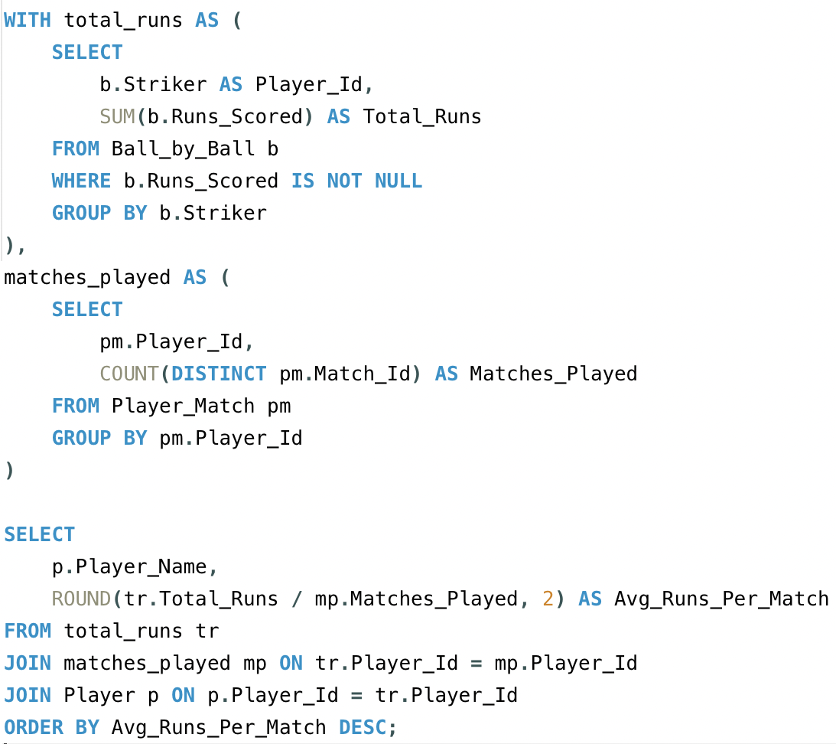

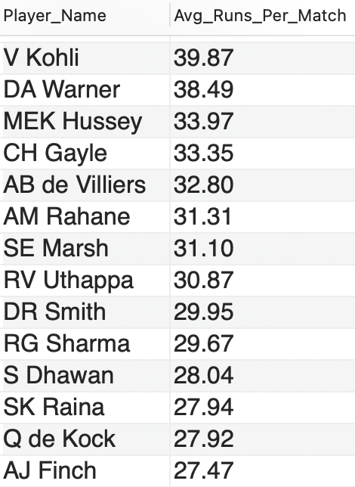

7.What are the average wickets taken by each bowler considering all the seasons?

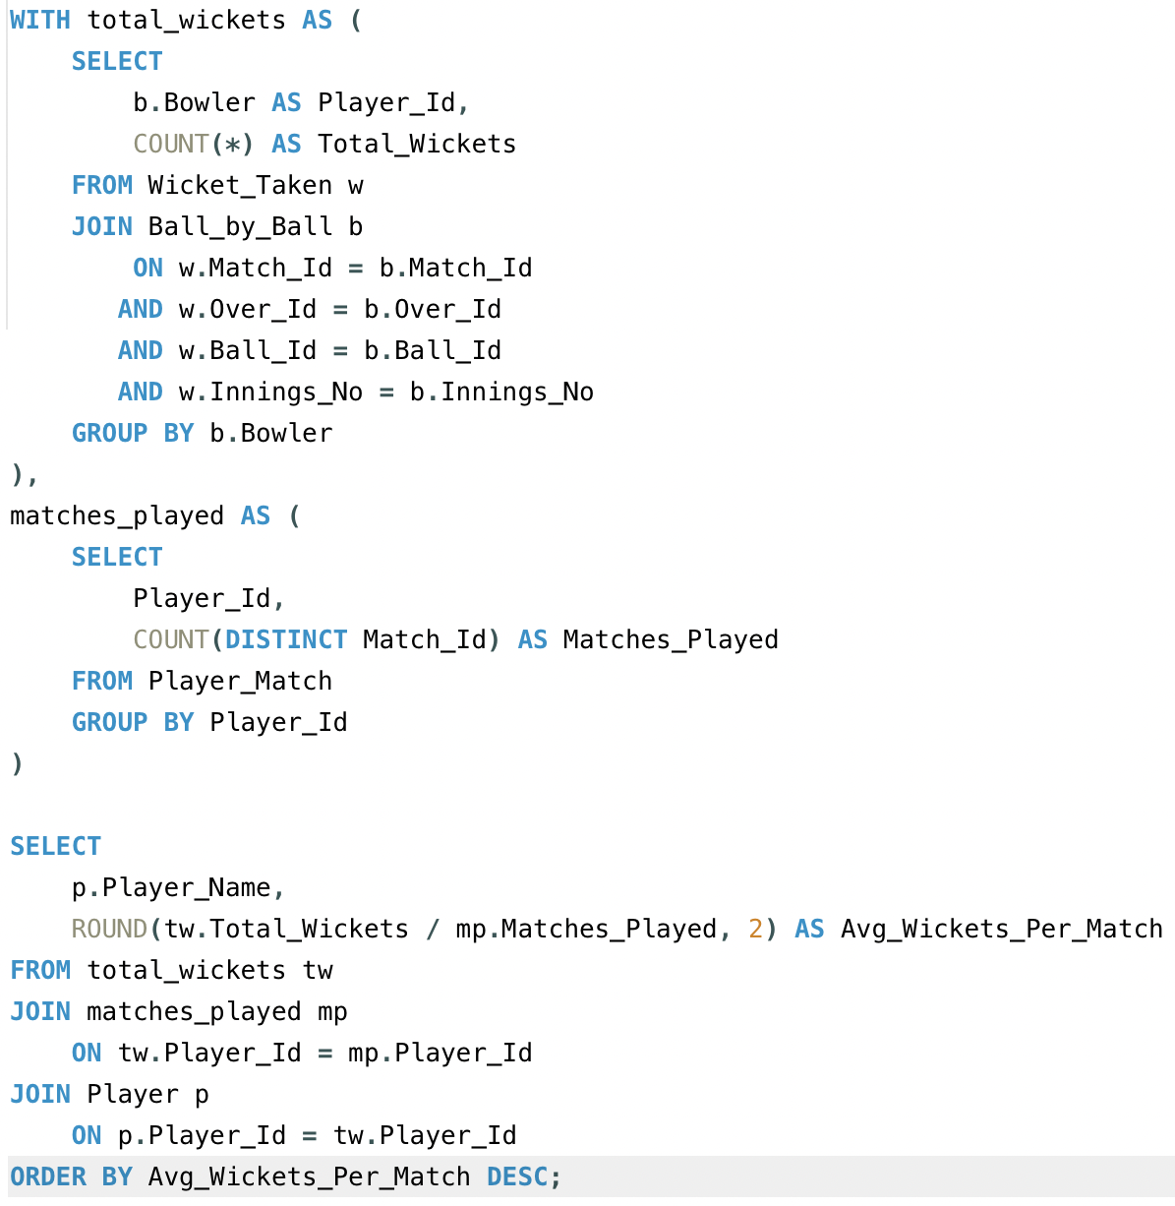

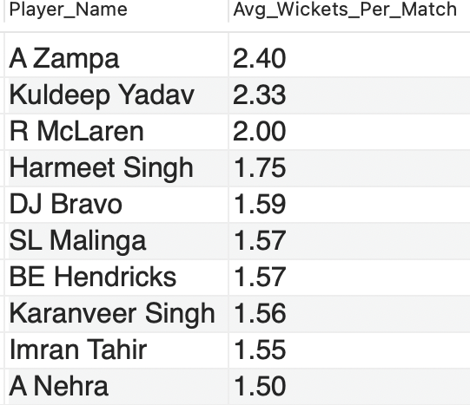

8. List all the players who have average runs scored greater than the overall average and who have taken wickets greater than the overall average

**Query Approach:**

We’ll solve this in three parts using Common Table Expressions (CTEs):

Part 1: Calculate average runs per batsman From the Ball_by_Ball table.

 Part 2: Calculate total wickets per bowler From the Wicket_Taken + Ball_by_Ball tables.

 Part 3: Calculate overall averages for both

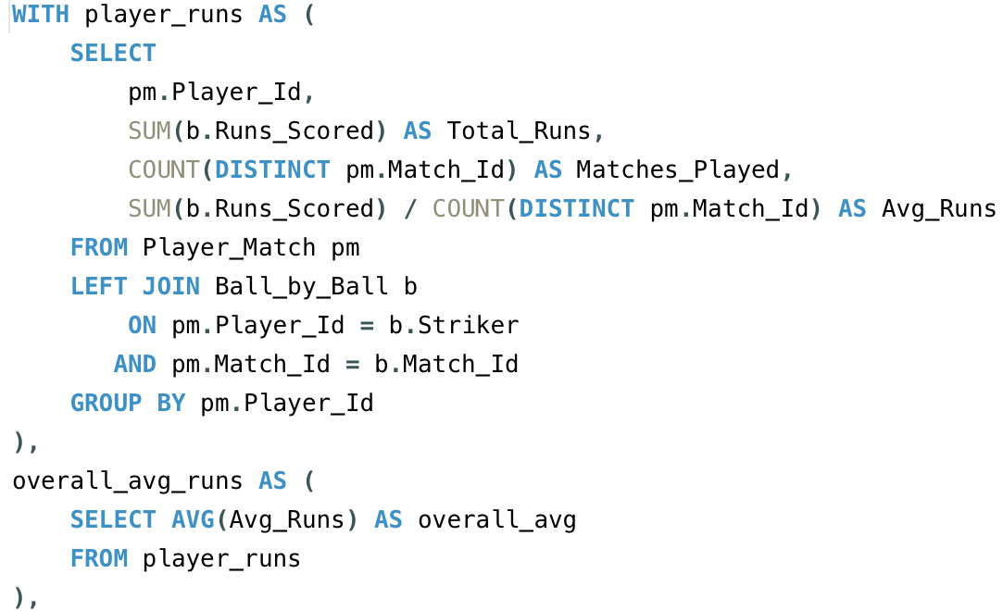

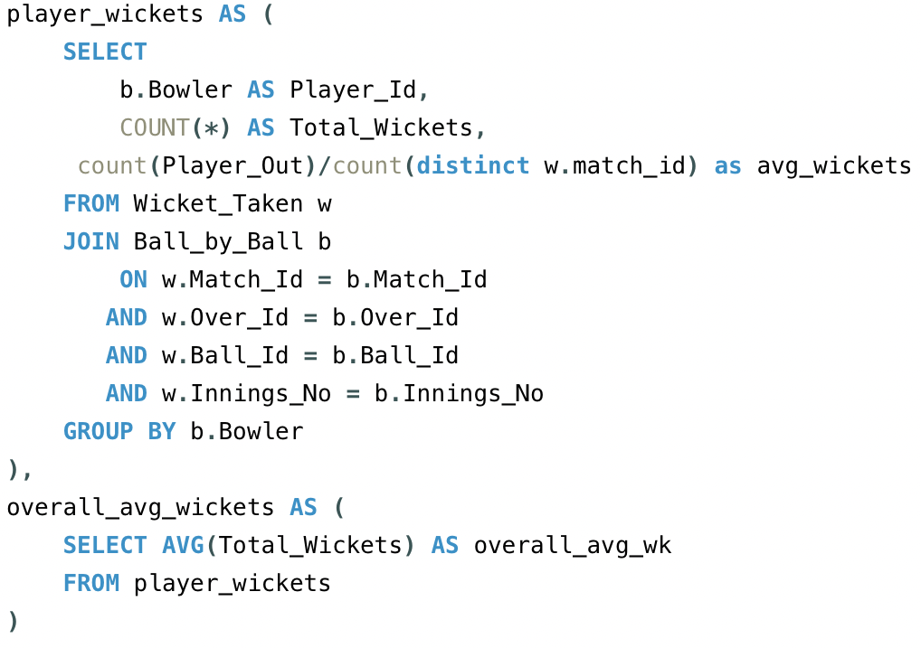

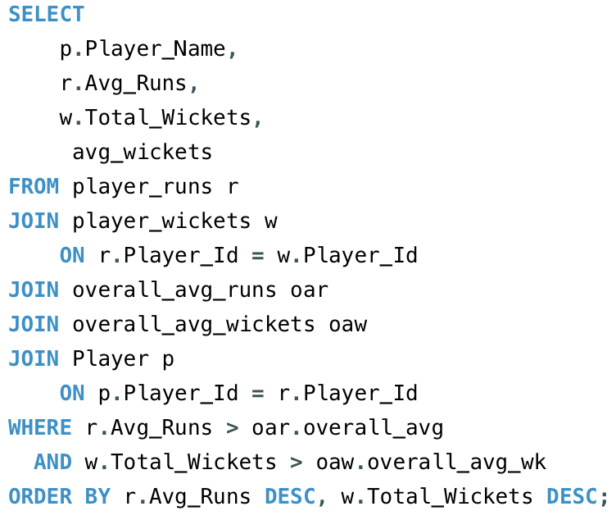

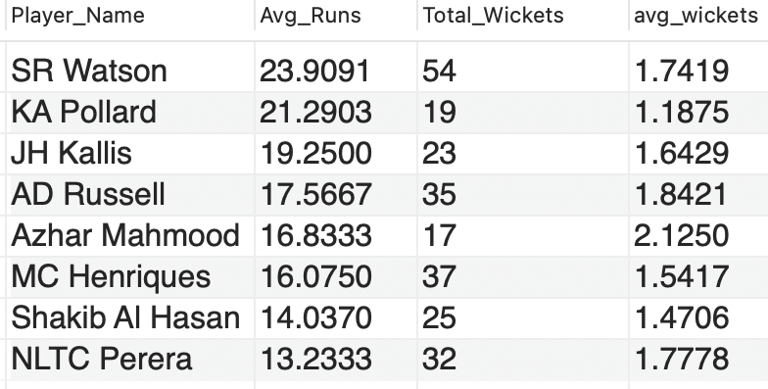

9. Create a table rcb_record table that shows the wins and losses of RCB in an individual venue.

Ans. Below is the rcb_record table that shows the win and losses of RCB in an individual venue:

**Table Required:**

* **Matches –** To get match outcome and venue
* **Team –** To get RCB team_id
* **Venue –** To show venue name

Query

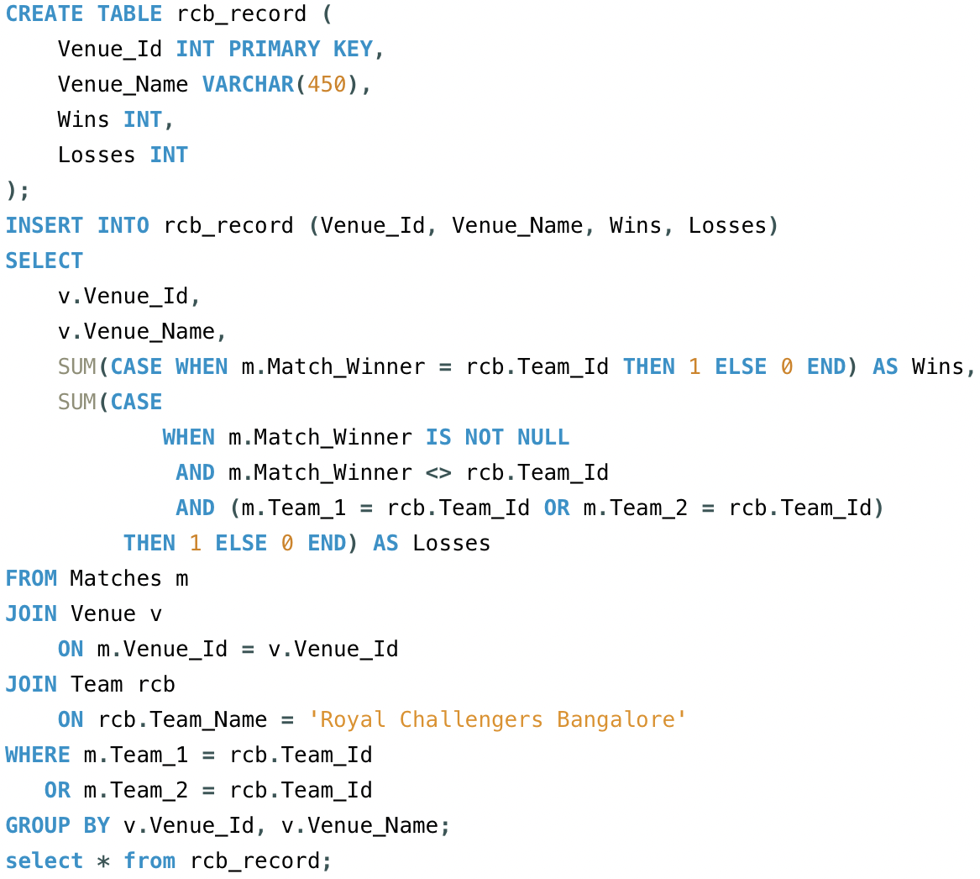

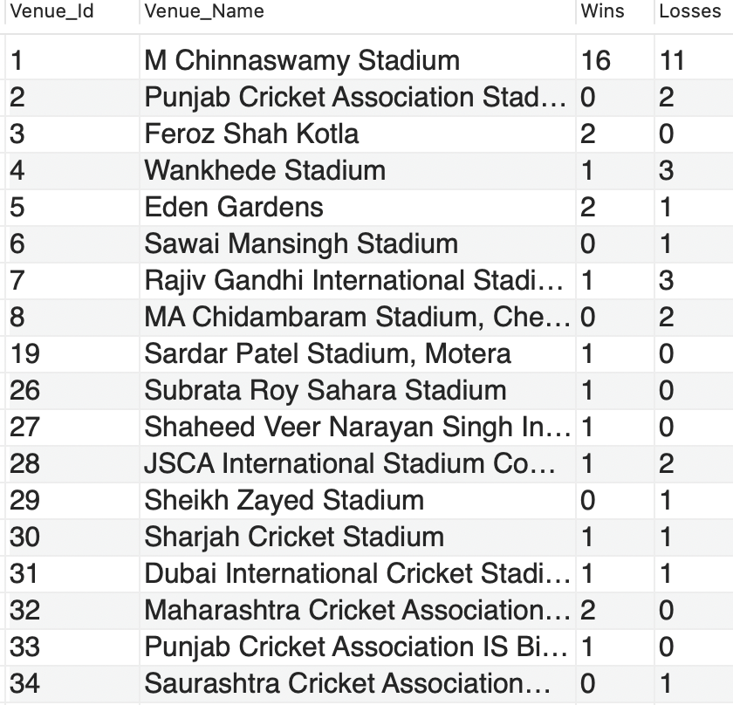

10. What is the impact of bowling style on wickets taken?

To Analyze the impact of bowling style on wickets taken, the following tables are required:

* **player**: To get information about the players, including their bowling style.
* **bowling_style**: To determine the type of bowling style associated with each player.
* **wicket_taken**: To get the details about the wickets taken by each bowler.
* **ball_by_ball**: To link the wickets taken with the bowler in each ball.

**Query Approach:**

* Identify each bowler's style.
* Count the total wickets taken by bowlers of each style.
* Compare the wicket counts to assess the impact of different bowling styles.

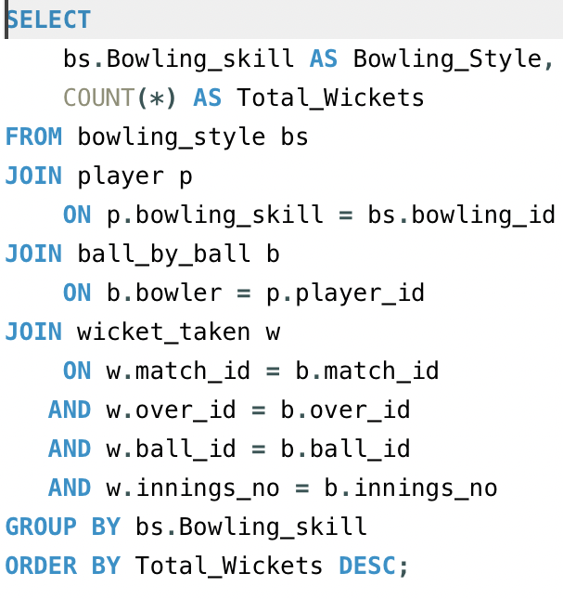

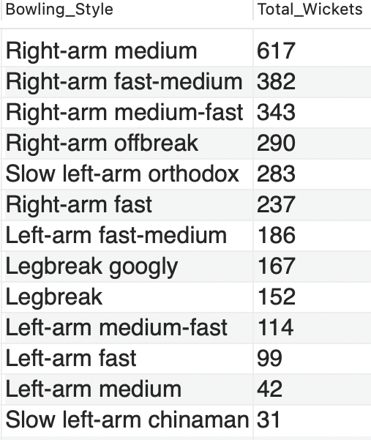

11.Write the SQL query to provide a status of whether the performance of the team is better than the previous year's performance on the basis of the number of runs scored by the team in the season and the number of wickets taken

Ans

**Table Required:**

* **Ball_by_ball -** Contains per-ball data (runs, overs, innings, batting/bowling team)
* **Matches -** Contains match-level details including season reference
* **Wicket_Taken -** Contains details of wickets
* **Season –** Contain season- year mapping
* **Team –** Contains team details

**Query Approach:**

* Aggregate total runs per team per season.
* Aggregate total wickets per team per season.
* Combine both to get team performance per season.
* Use LAG() to get the previous year’s performance for the same team.
* Compare current vs. previous to determine if the team improved, declined, or stayed the same.

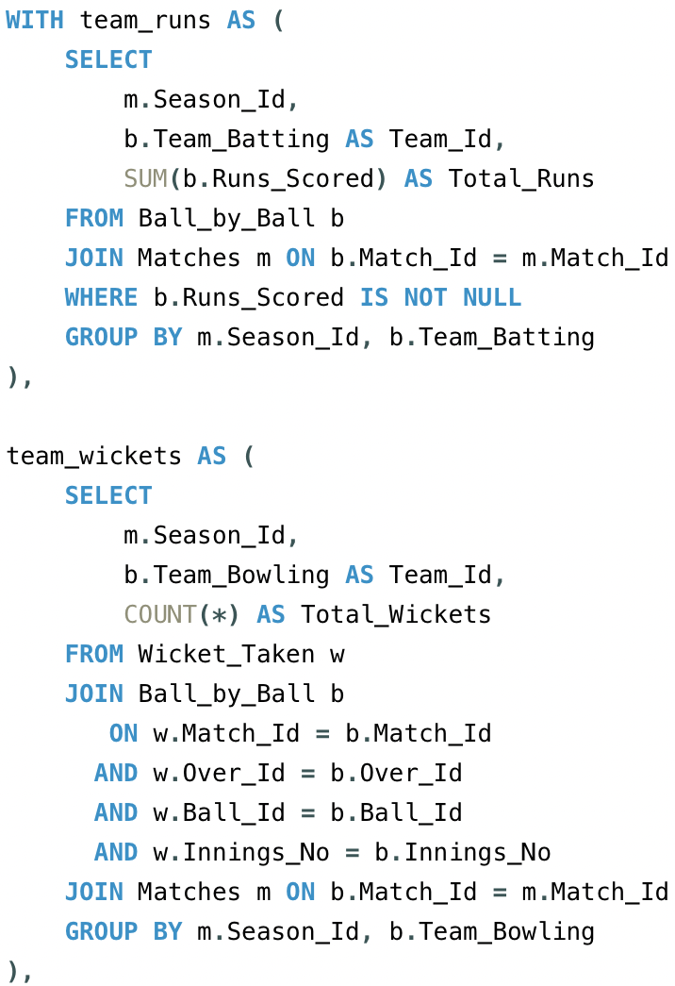

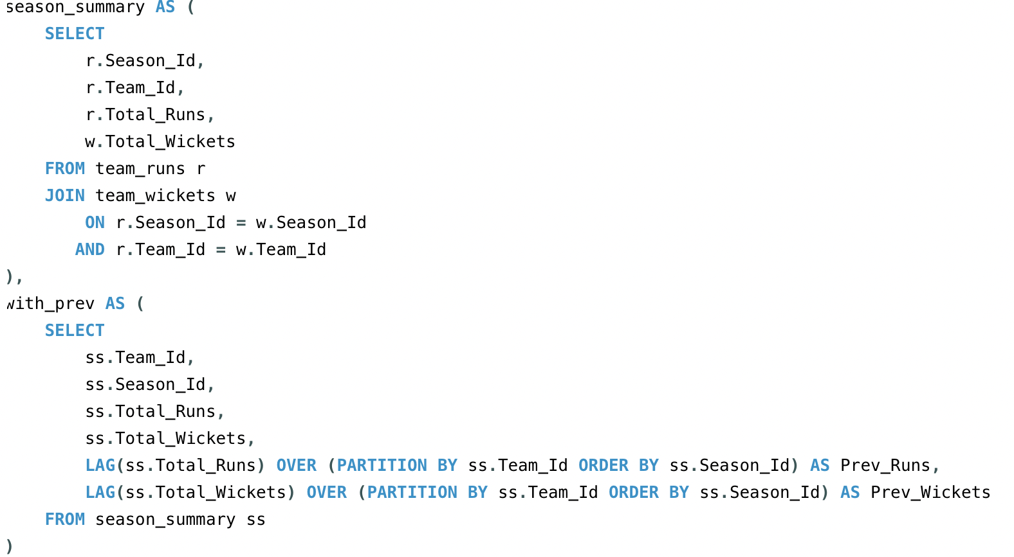

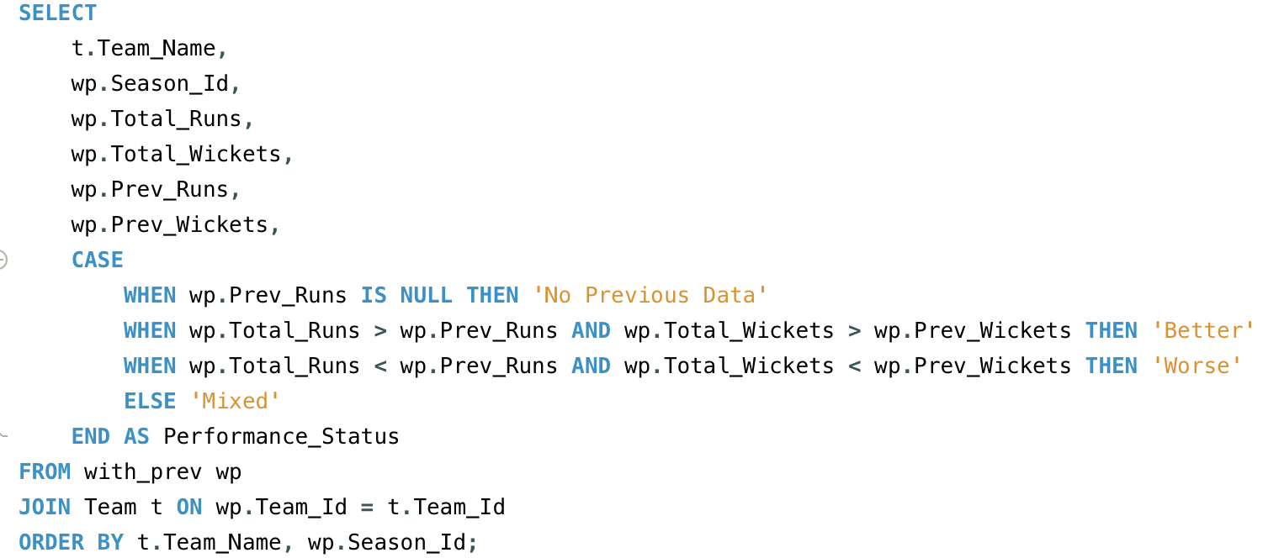

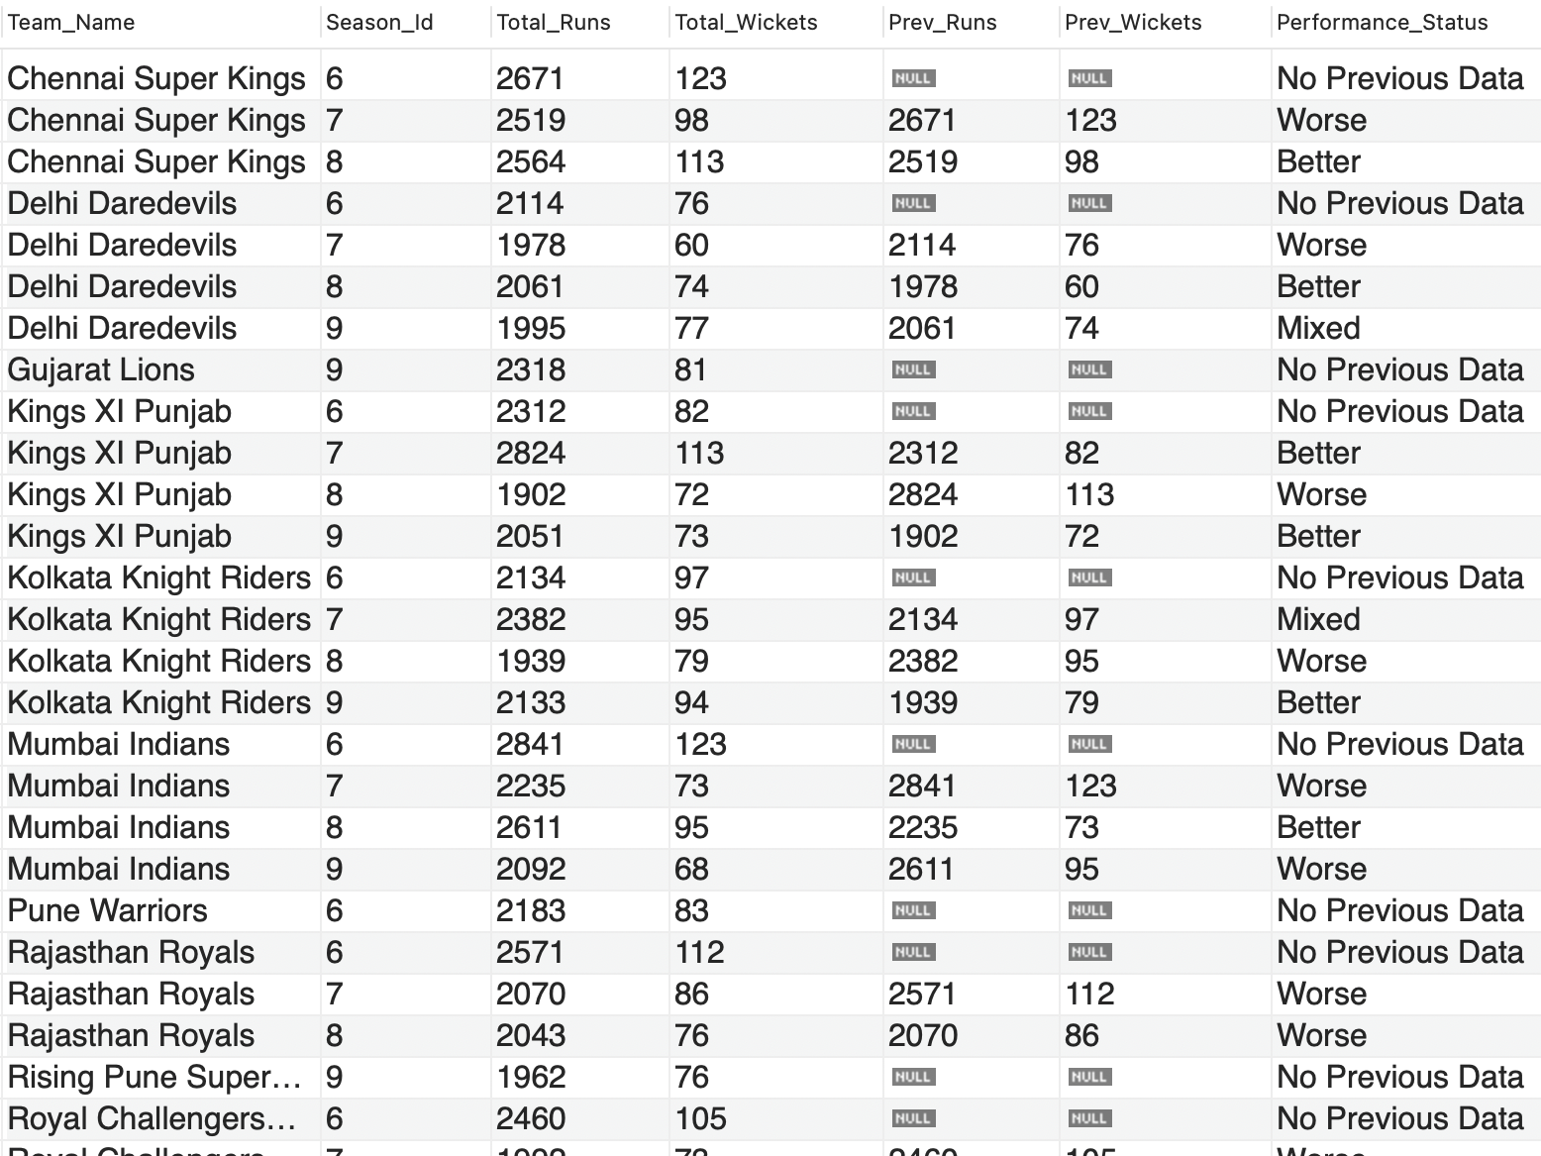

12. Can you derive more KPIs for the team strategy?

Ans. Top 5 KPIs for Team Strategy (with Formula):

I derived the following 5 KPIs from the dataset to help analyse team performance and strategy. These KPIs are calculated using the data available:

**1. Win Percentage:**

Formula:

**(Number of Matches Won/Number of Matches Played​) ×100**

Tables & Columns Used:

Matches table:

* Match_Winner – to identify which team won
* Team_1, Team_2 – to count total matches a team played

This helps evaluate a team's overall success rate.

**Query Approach:**

Use the Matches table, filter by team as MatchWinner, and divide the number of wins by matches played.

**Query:**

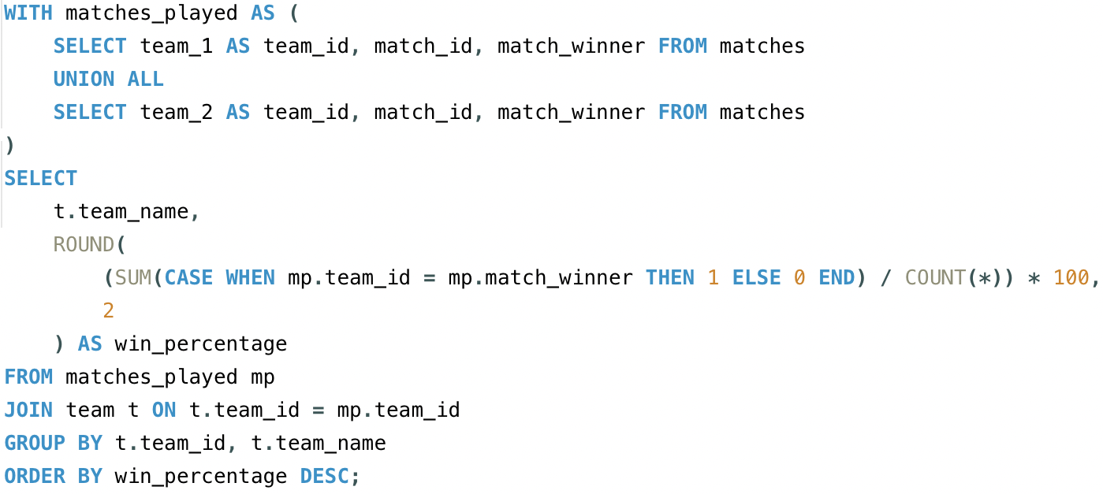

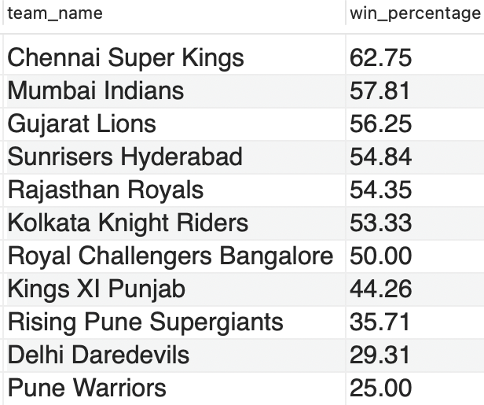

**2. Average Runs per Match:**

Formula:

**(Total Runs Scored​ / Total Matches Played​)**

Tables & Columns Used:

Ball_by_Ball table:

* Runs_Scored – the runs scored per ball
* Team_Batting – which team scored the run

Matches table:

* Match_Id – to count unique matches per team

Useful for understanding the team's scoring consistency.

**Query Approach:**

* Join the ball_by_ball, matches, and team tables to relate runs scored to the team and match context.
* Filter/group by batting team to sum up runs for each team.
* Count unique matches played (using COUNT(DISTINCT m.match_id)) to get matches per team.
* Divide total runs by total matches to calculate the average per team.

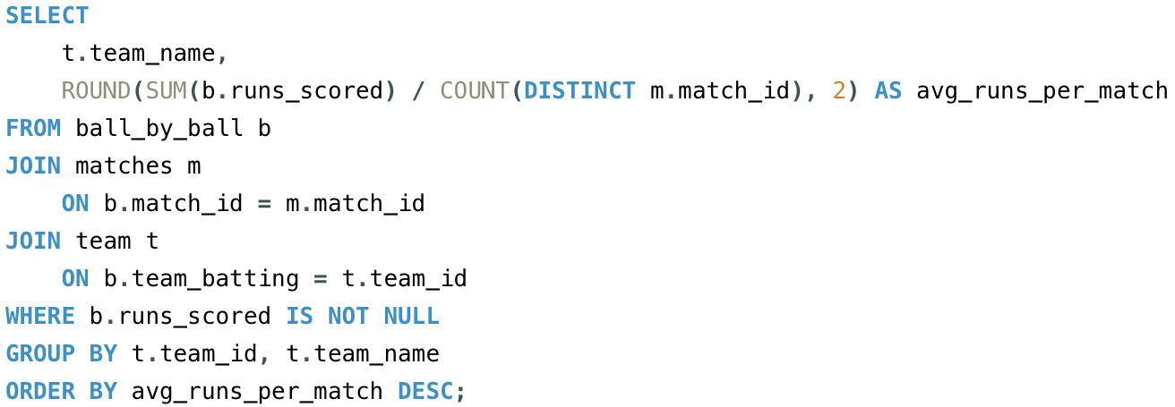

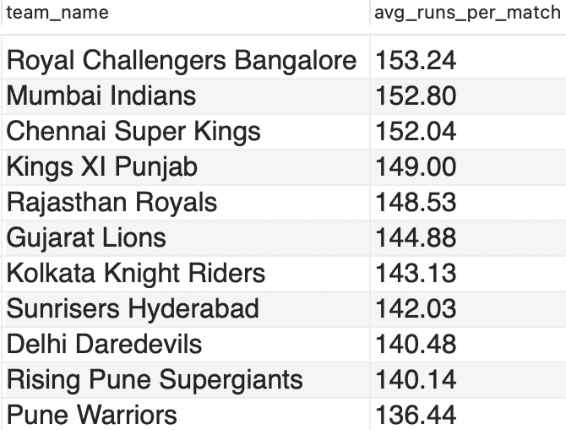

**3. Average Wickets per Match:**

Formula:

**(Total Wickets Taken​​ / Total Matches Played​)**

Tables & Columns Used:

Wicket_Taken table:

* Player_Out – identifies a wicket taken

Ball_by_Ball table:

* Team_Bowling – to know which team took the wicket

Matches table:

* Match_Id – to group wickets match-wise

This shows the bowling strength of a team

**Query Approach:**

* Join wicket_taken with ball_by_ball to relate each wicket to the team bowling that ball.
* Join matches to associate matches context.
* Join the bowling team for readable output.
* Count total wickets using the player_out column in wicket_taken for each team.
* Count unique matches bowled by each team.
* Divide total wickets by total matches to get average wickets per match.

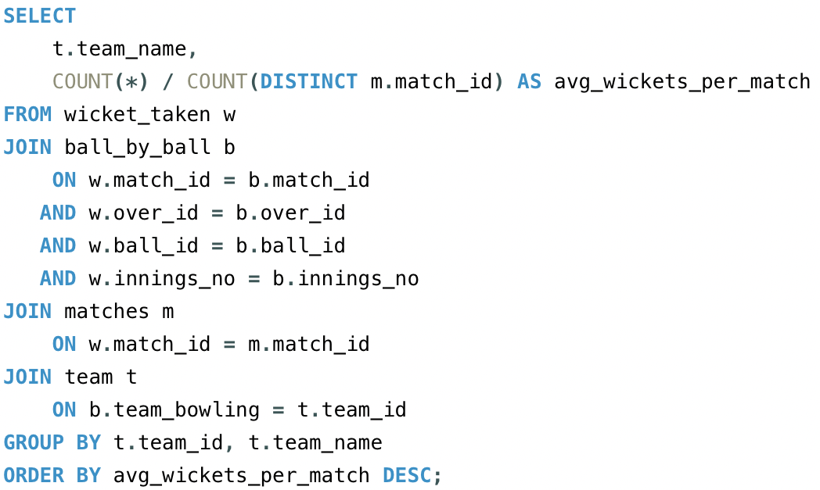

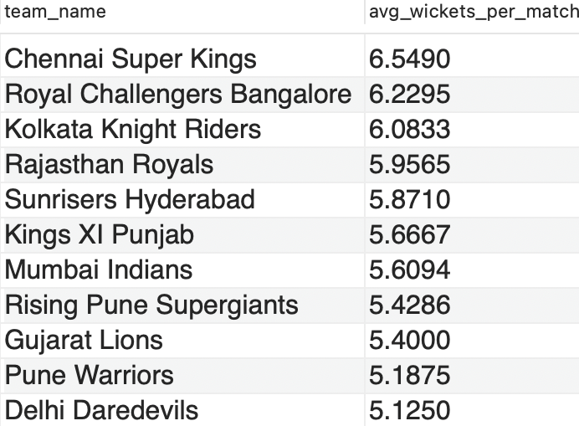

**4. Run Rate:**

Formula:

**(Total Runs Scored​​​ / Total Overs Faced​)**

Tables & Columns Used:

Ball_by_Ball table:

* Runs_Scored – for total runs
* Over_Id – to calculate total overs
* Team_Batting – to group by team

Helps understand how quickly a team scores runs.

**Query Approach:**

* Join ball_by_ball and team to relate runs to teams.
* Sum runs scored for each team.
* Count all balls faced
* Divide runs by overs to get the overall run rate for each team.
* Count matches if differentiating between average per match and total run rate.

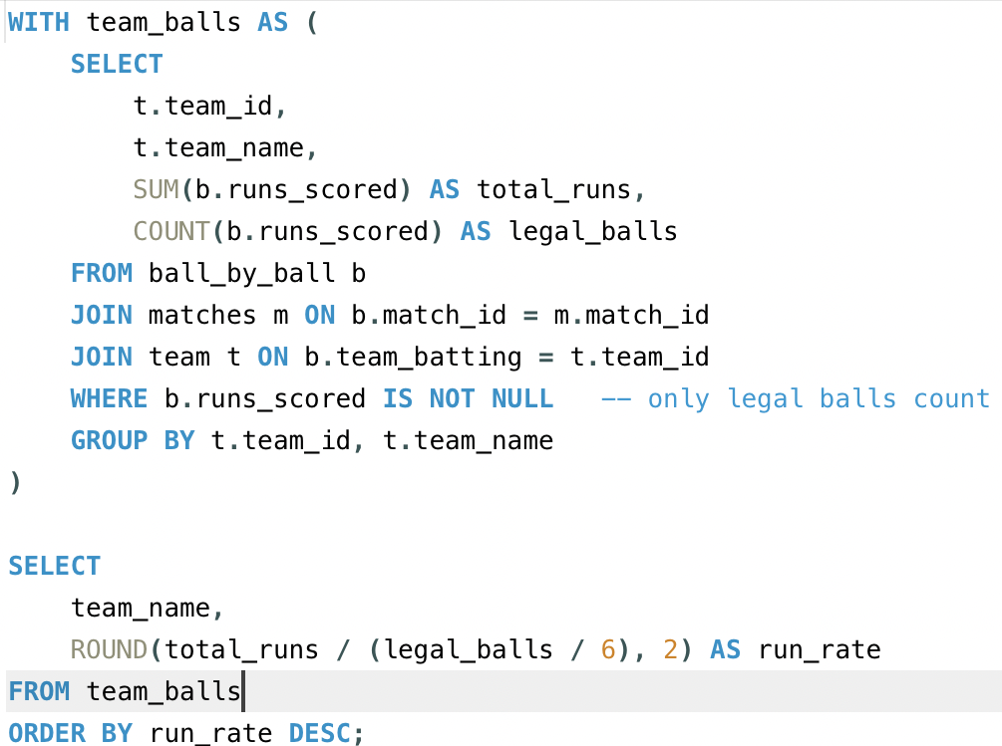

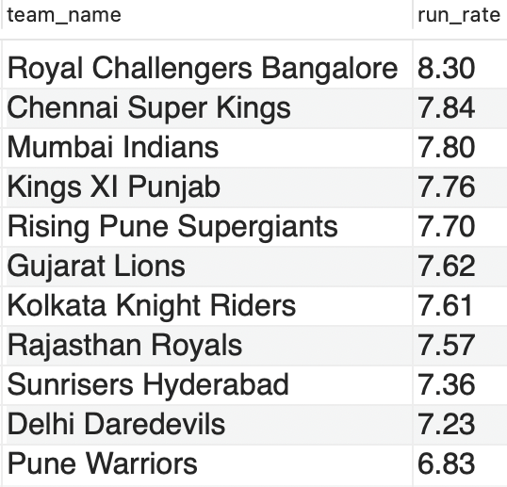

**5. Toss Impact KPI:**

Formula:

**Win % After Toss Decision (Bat/Field):**

**(Matches Won After Toss Decision / Matches with That Toss Decision) * 100**

Understand if choosing to bat or field first affects performance.

Tables & Columns Used:

Matches table:

* Toss_Winner – to identify which team won the toss
* Toss_Decide – to check if the team chose to bat or field
* Match_Winner – to verify if the toss-winning team also won the match

Team table:

* Team_Id, Team_Name – to display readable team names in the output

Helps evaluate whether teams make the right decision after winning the toss and how it affects their chances of winning.

**Query Approach:**

* Join matches and team on the toss winner to get readable team names.
* Join matches and toss_decision on the toss_decide column to get the toss decision name.
* Group by team and toss decisions to separate results for each decision per team.
* Calculate win percentage using a conditional count where the toss winner is also the match winner, divided by total matches for that toss decision.
* Order by team and toss decisions for clear output.

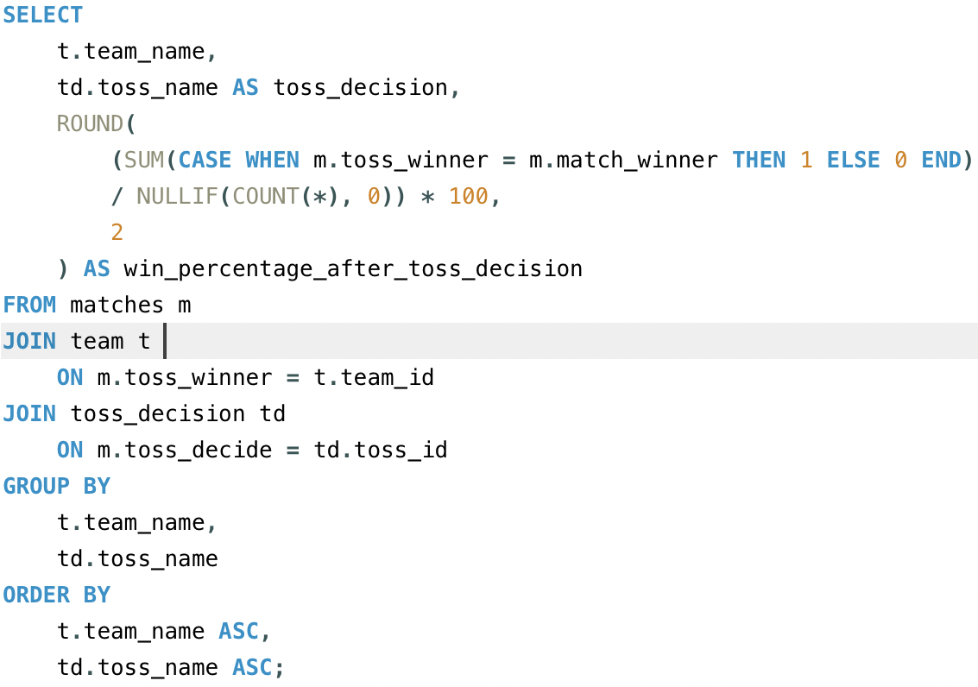

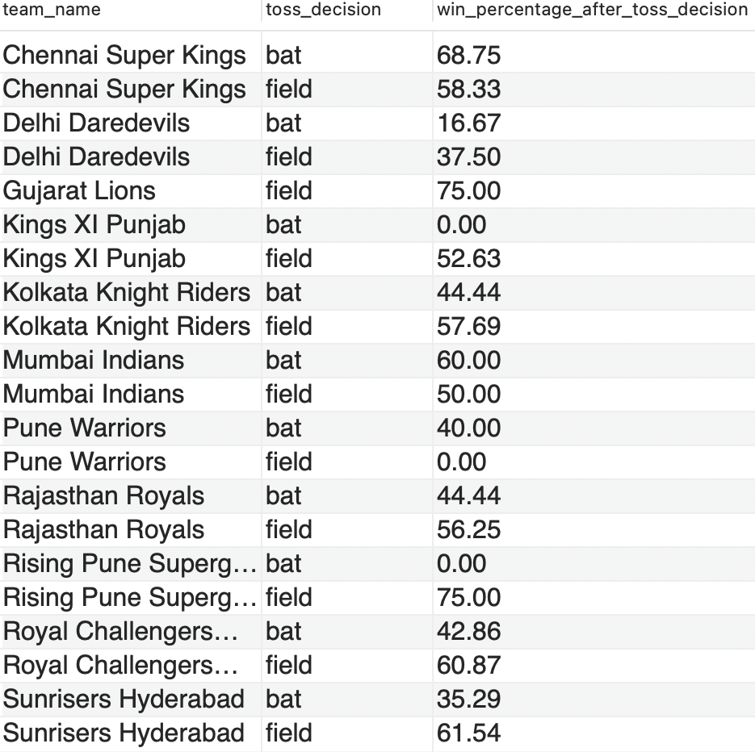

13. Using SQL, write a query to find out the average wickets taken by each bowler in each venue. Also, rank the gender according to the average value.

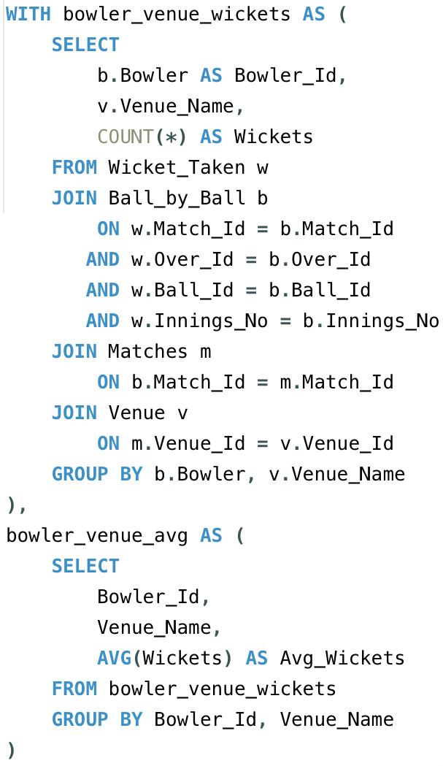

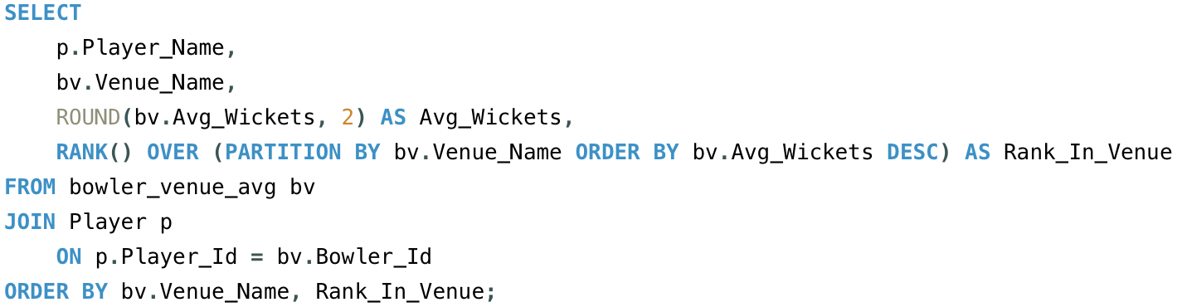

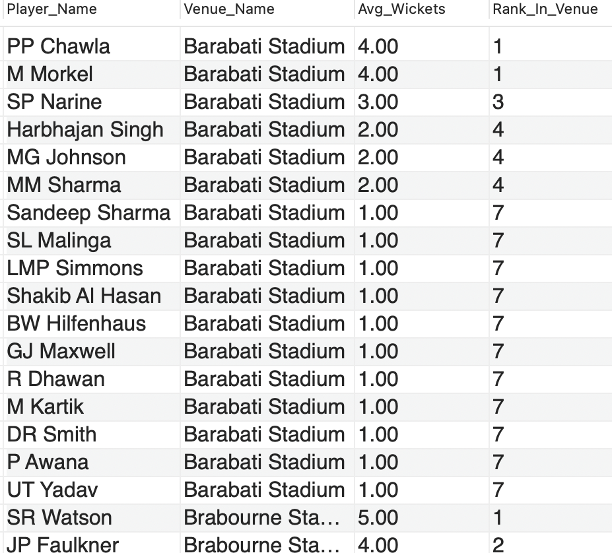

14. Which of the given players have consistently performed well in past seasons? (will you use any visualization to solve the problem)

**Ans.** **To find out which players have consistently performed well in past seasons, I looked at two main performance indicators:**

1. **Runs scored by each batsman in every season**
2. **Wickets taken by each bowler in every season**

I grouped the data season-wise and player-wise, and checked if players performed above average in multiple seasons, not just in one. Players who scored high runs or took many wickets across 3 or more seasons were considered consistent performers.

Step-by-Step Process:

**1. For Batsman – Season-wise Runs Scored**

The following SQL query to get the total runs scored by each batsman in every season:

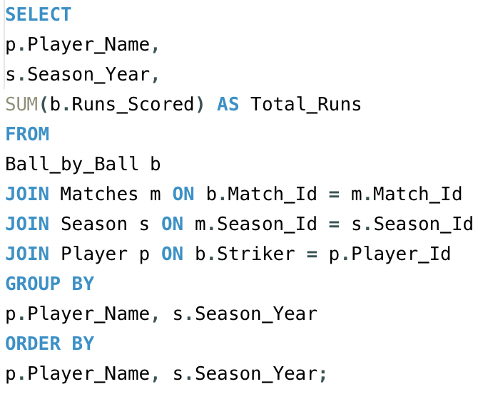

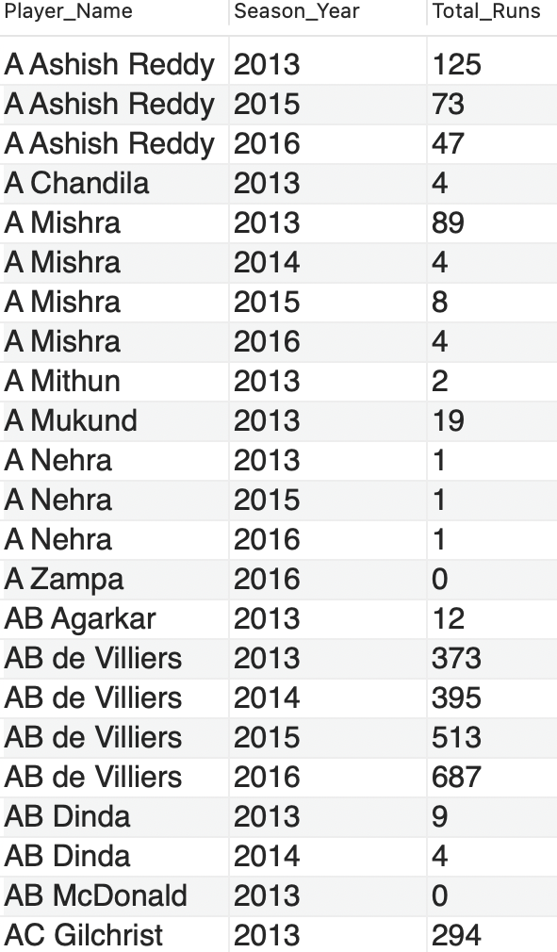

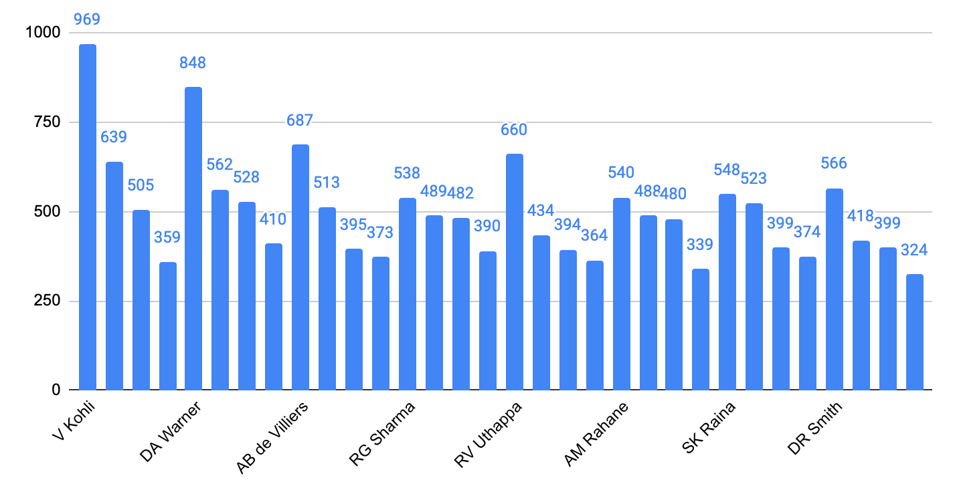

**2. For Bowlers – Season-wise Wickets Taken**

To find how many wickets each bowler took in every season, I used this query:

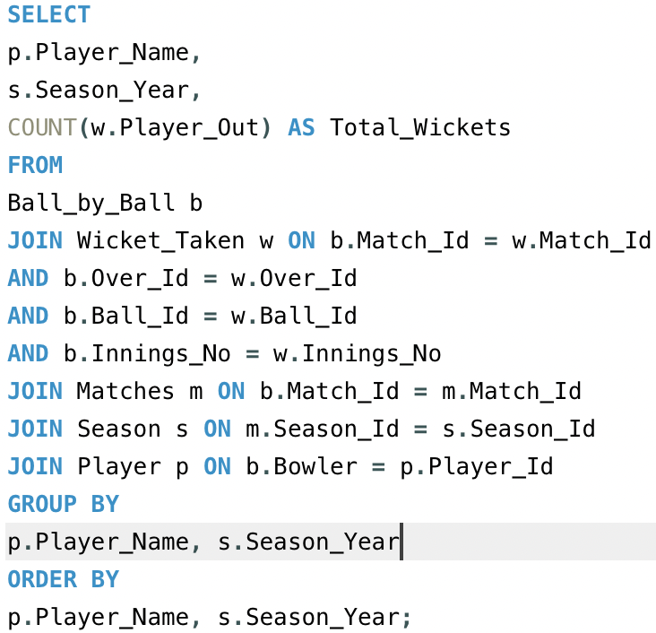

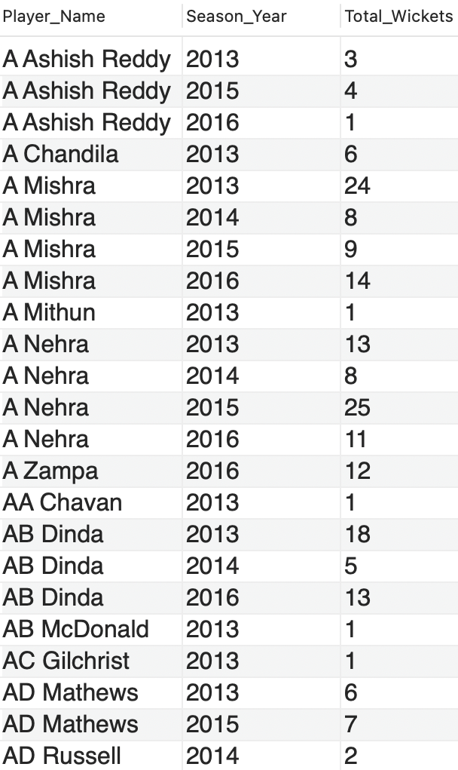

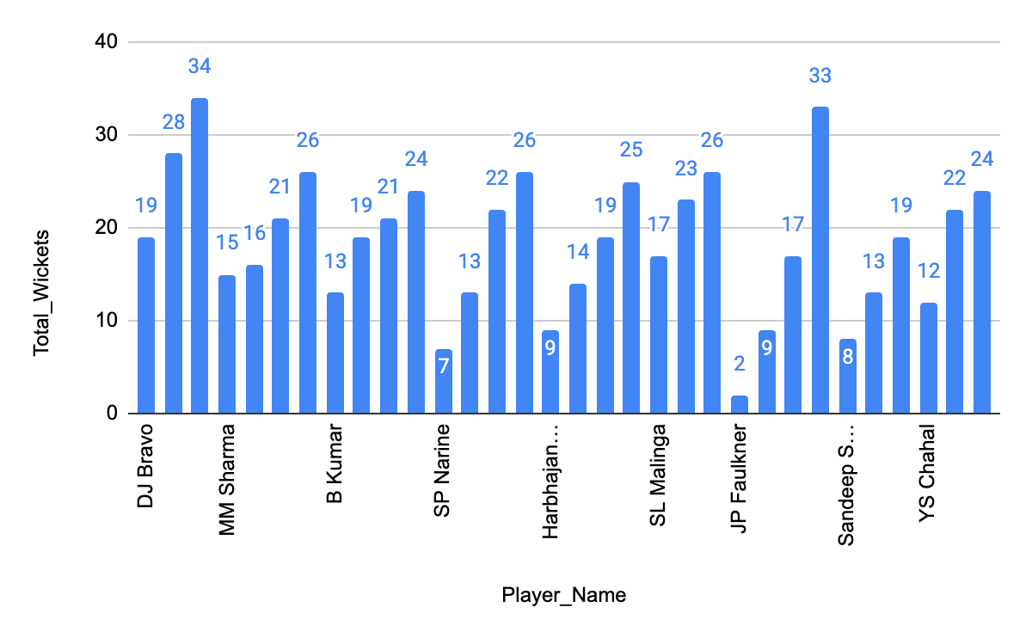

15. Are there players whose performance is more suited to specific venues or conditions? (how would you present this using charts?)

**Ans.** There are players whose performance is more suited to specific venues. Some players consistently score more runs or take more wickets at particular grounds due to pitch type, stadium conditions, or home advantage.

**Step 1: Write SQL Queries to Get Player-Venue Performance:**

**For Batsman (Runs per Venue):**

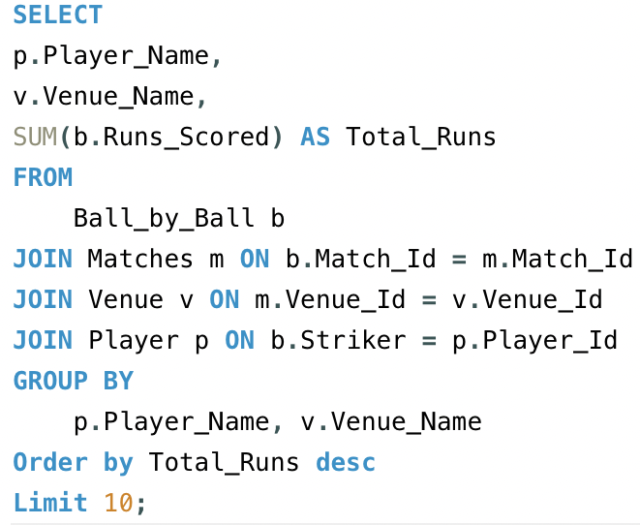

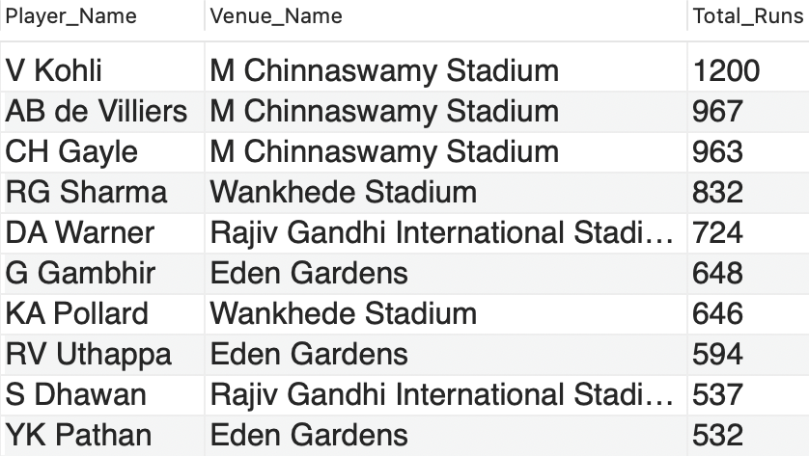

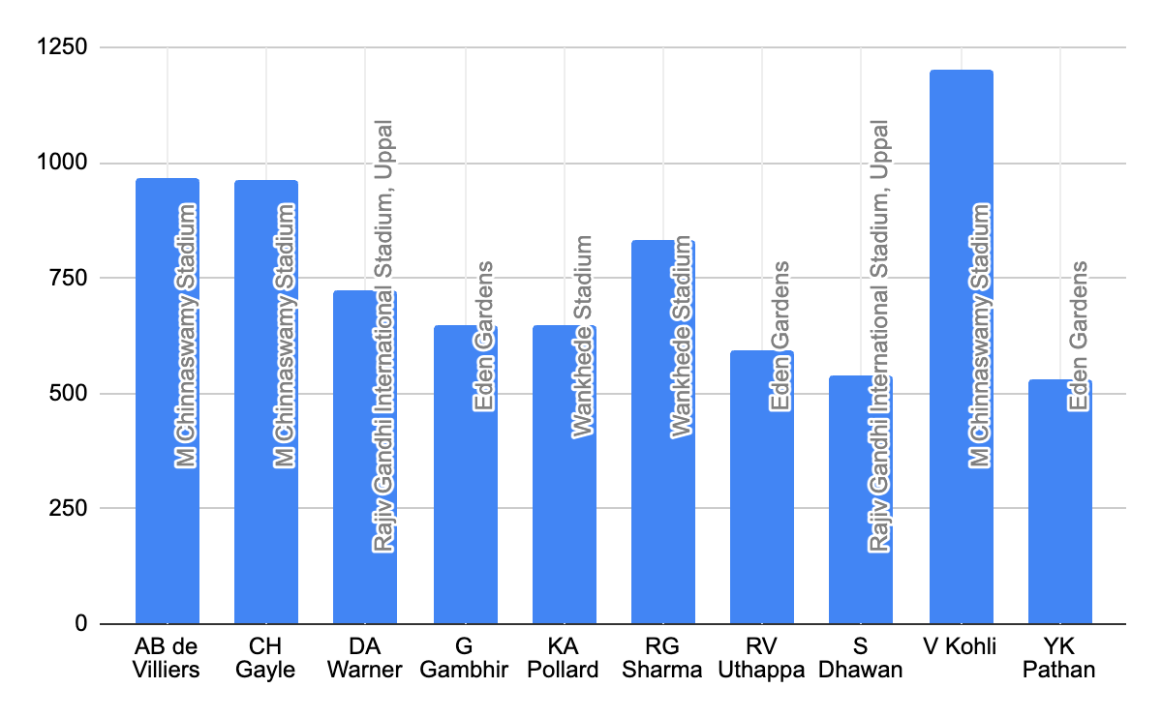

**For Bowlers (Wickets per Venue):**

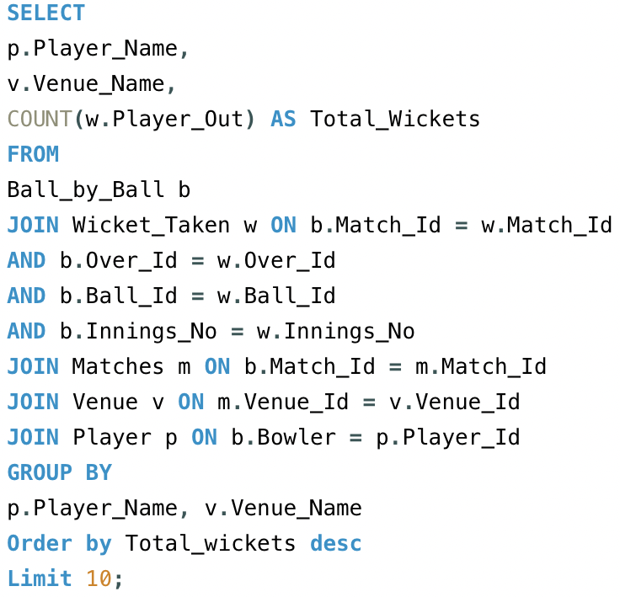

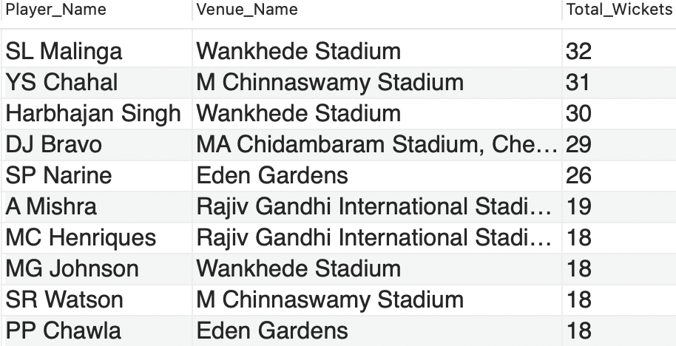

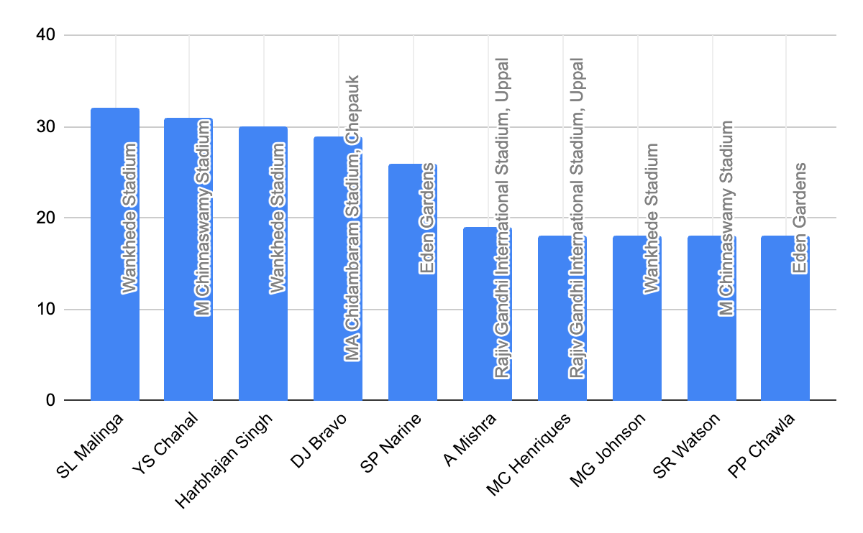

Subjective Questions

1. How does the toss decision affect the result of the match? (which visualizations could be used to present your answer better) And is the impact limited to only specific venues?

**Ans.** To understand how toss decisions have influenced match results, we need to Analyze data from three key tables:

**Tables Required**

* **matches:** To identify the toss winner, match winner, and link with venue and toss decisions.
* **toss_decision:** To determine whether the toss-winning team chose to bat or bowl.
* **venue:** To identify the venue of the match for venue-specific analysis.

**Query Approach**

* Aggregate data to show only venues with a significant number of matches (e.g., at least 10) to focus on more relevant insights.
* Calculate the win percentage for each toss decision at these venues to identify patterns.
* Sort and limit the results to highlight the top 10 most relevant venue-toss decision combinations.

**Insights**

* **Venue-Specific Impact:** Certain venues show a stronger relationship between toss decisions and match outcomes, indicating that these decisions play a crucial role in match strategy.
* **High Win Percentages:** At some venues, winning the toss and making a specific decision (batting or bowling) significantly increases the chances of winning.
* **Strategic Importance:** Teams may benefit from analyzing venue-specific data to optimize their toss decisions and improve match outcomes.

**Recommendations:**

* **Data-Driven Decisions:** Teams should leverage venue-specific toss data to guide their decisions, particularly at venues with a high impact of toss decisions on match outcomes.
* **Venue Strategy:** Focus on venues where toss decisions have historically influenced match results to gain a strategic advantage

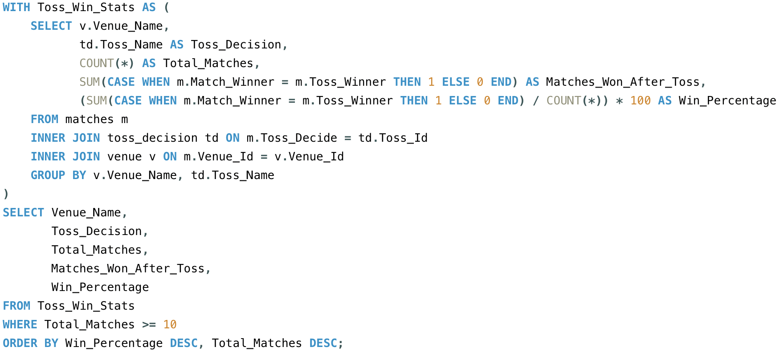

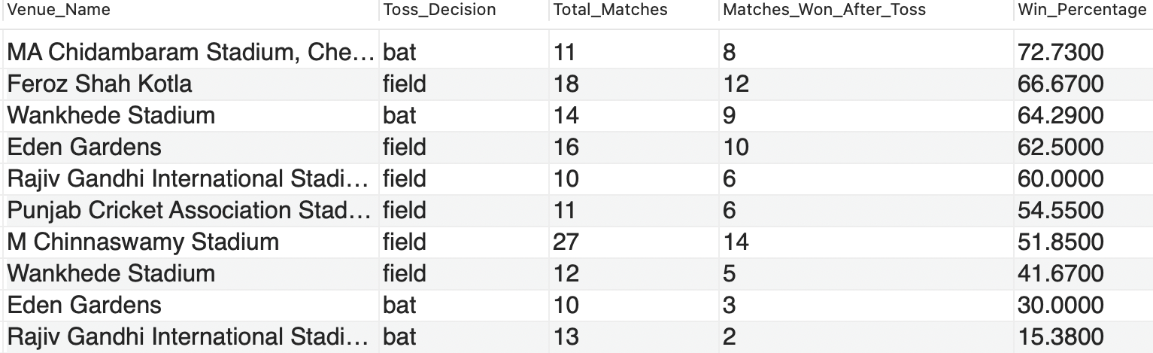

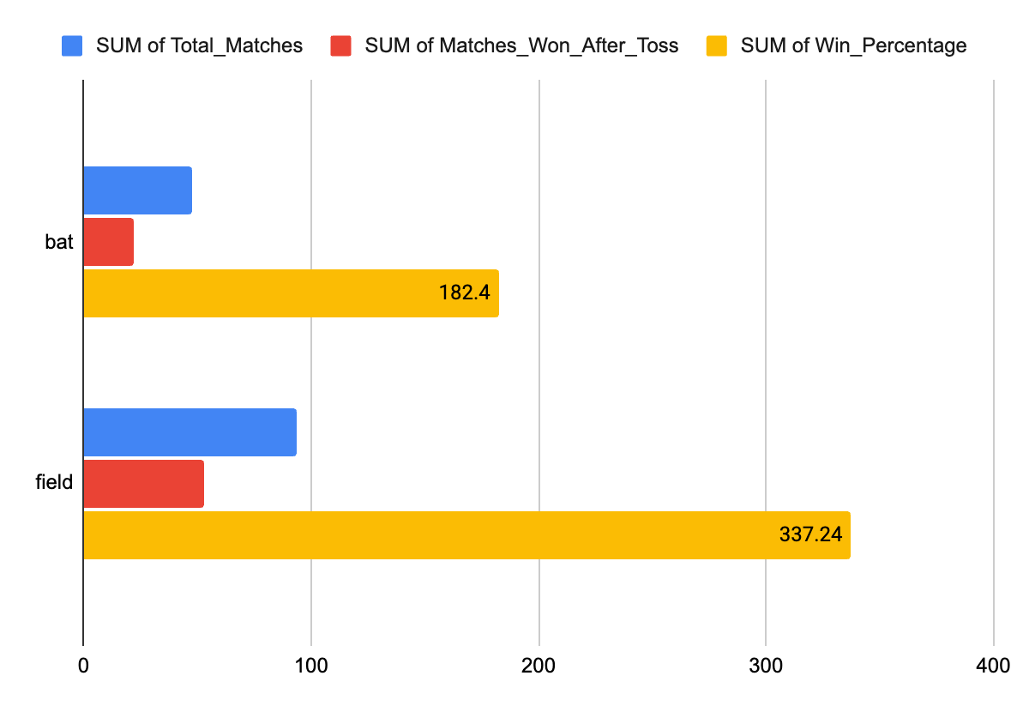

2. Suggest some of the players who would be best fit for the team.

**Ans.** To suggest the best players for the team, I analysed the performance data of all players across multiple IPL seasons. I looked at both batsmen and bowlers, and selected players who showed consistency, match-winning ability, and good performance across different venues.

How I selected the best players:

For Batsman, I checked:

* Total Runs
* Batting Average
* Strike Rate
* Performance in different venues

For Bowlers, I checked:

* Total Wickets
* Bowling Average
* Economy Rate
* Consistency over seasons

**Query:**

**Top 10 Batsmen with High Average Runs:**

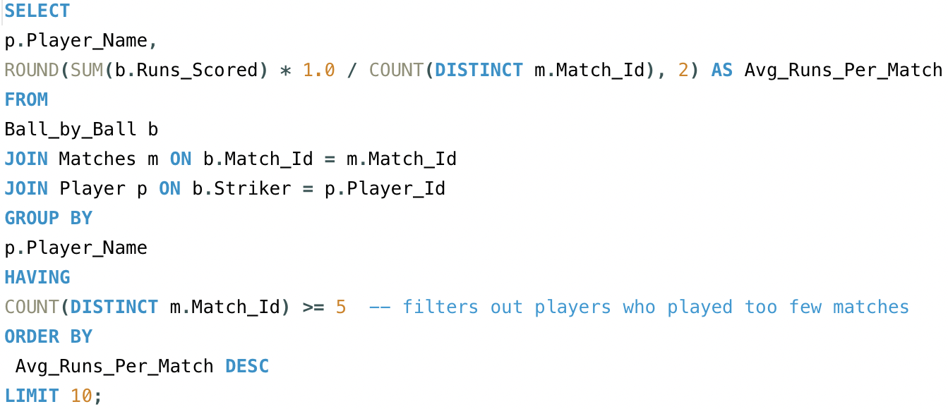

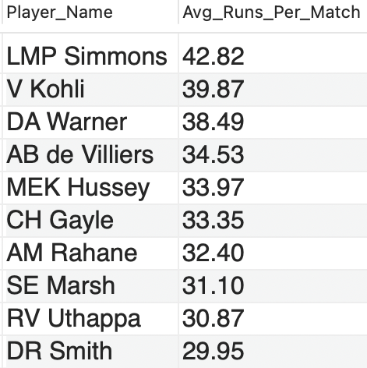

**Top 10 Bowlers with Average Wickets:**

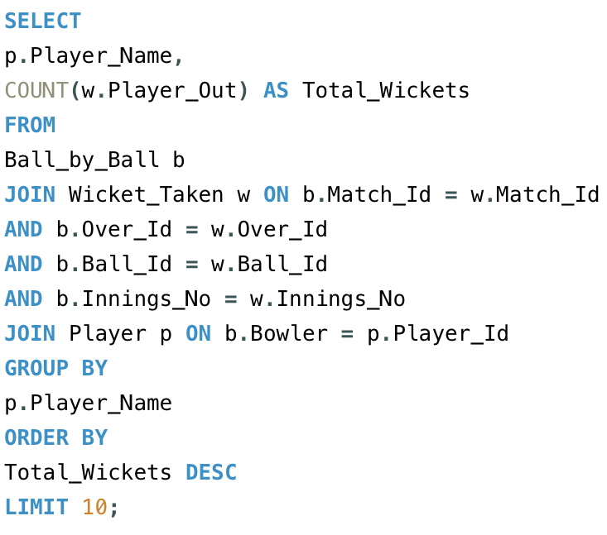

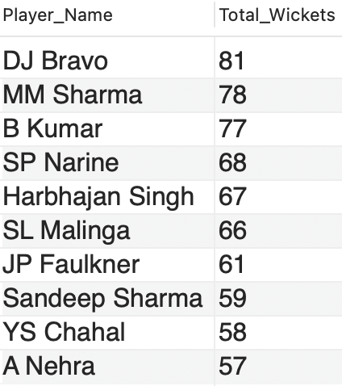

3. What are some of the parameters that should be focused on while selecting the players?

**Ans.** To focus on the key parameters while selecting the best players, this query aims to identify top-performing players by analyzing their batting and bowling statistics. This includes total runs scored, average runs per match, strike rate, and total wickets taken. The goal is to select players who excel in both batting and bowling, ensuring they contribute significantly to team performance.

**Tables Required:**

* **player**: To get the player's name and unique identifier.
* **ball_by_ball**: To track each ball's outcome and identify the players involved and runs scored by the player.
* **wicket_taken**: To track the wickets taken by each player.

**Approach:**

* **Player Details**: The **player** table is used to identify the player names.
* **Ball-by-Ball Data**: Join with the **ball_by_ball** table to link each ball event with players.
* **Wickets**: Use the **wicket_taken** table to count the number of wickets taken by each player (bowler).
* **Calculation**: Calculate the strike rate and average runs per match for top 10 players based on total runs.
* **Final Output**: Fetch and limit the top 10 players ordered by total runs.

**Insights:**

* **Top Run-Scorers**: Identifies the players with the highest total runs in the IPL, providing a measure of their batting performance.
* **All-Rounders**: Players with both significant runs and wickets are valuable all-rounders, essential for team balance.
* **Strike Rate Impact**: Players with higher strike rates offer greater impact in limited-overs games, particularly in high-pressure overs.

**Recommendations:**

* **Focus on High Performers**: Prioritize players who consistently deliver runs and have high strike rates, as they play a critical role in winning matches.
* **All-Rounder Strategy**: Select all-rounders who contribute significantly with both the bat and ball, providing extra flexibility in team composition.

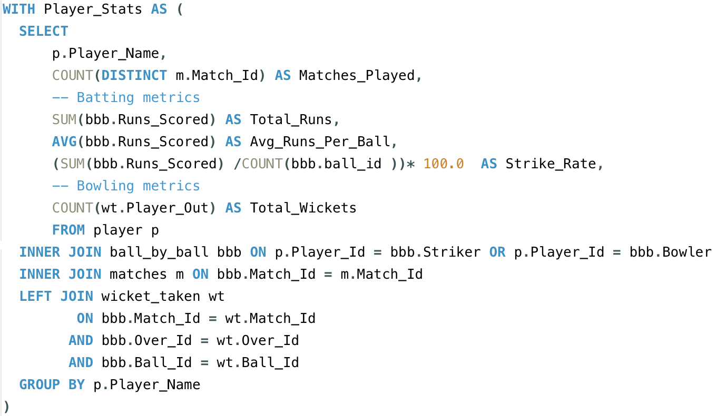

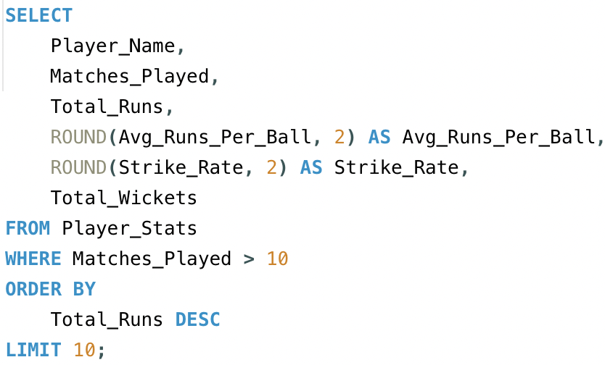

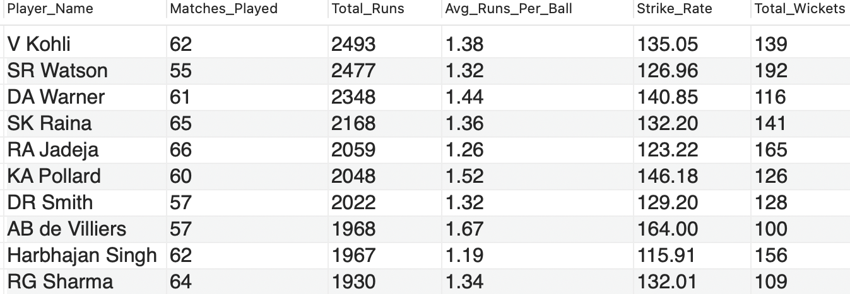

4. Which players offer versatility in their skills and can contribute effectively with both bat and ball? (can you visualize the data for the same)

Ans

**Approach:**

Some players are not just good at one skill — they are valuable all-rounders, meaning they score runs and take wickets regularly. These players are very useful in T20 matches, as they add balance to the team.

**To find such players, I used a single SQL query that calculates:**

* Total runs scored (as batsman)
* Total wickets taken (as bowler)
* And filters players who have both decent runs and wicket counts

**Insights:**

From the visualization, SR Watson leads the list with an outstanding impact score of 2395, making him the top all-round performer. He is followed by RA Jadeja (1790), who provides consistent balance with both bat and ball. MC Henriques (1383) and AD Russell (1227) also show strong all-round capabilities, though at a slightly lower impact level.

**Recommendations:**

**1. Prioritize Genuine All-Rounders for Better Team Balance:**

Teams should focus on acquiring players who consistently perform above average in both batting and bowling metrics (strike rate, runs scored, wickets taken, and economy rate). These players provide flexibility in team combinations and reduce dependence on single-skill specialists.

**2. Strengthen Middle Overs and Finishing Through Versatile Players:**

All-rounders who can anchor the middle overs and bowl economically between overs 7–15 add immense value. Similarly, batting all-rounders who can finish innings while contributing with the ball give the team depth in both departments.

**3. Target Players Who Fit Venue Conditions:**

For high-scoring venues (like Chinnaswamy), teams should prefer all-rounders with high strike rates and death bowling capability. For lower-scoring grounds, spinning all-rounders or seam-bowling all-rounders with strong control become more valuable.

**4. Build a Long-Term Core Around 2–3 Strong All-Rounders**

Successful teams often have a stable core of all-rounders who contribute consistently season after season. Teams should invest in players who offer long-term value instead of short-term fixes.

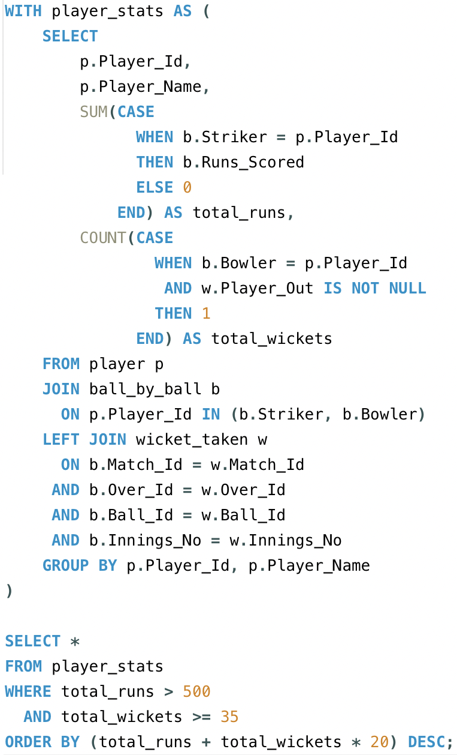

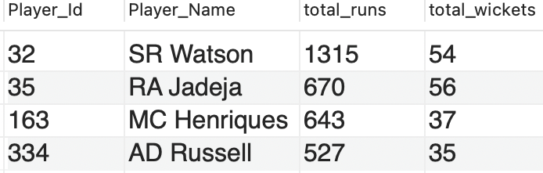

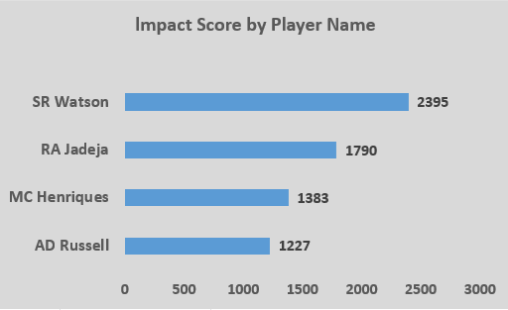

5. Are there players whose presence positively influences the morale and performance of the team? (justify your answer using visualization)

**Ans.** Yes, there are certain players whose presence seems to have a positive impact on the team’s overall performance. These players may not always be the highest scorers or wicket-takers in every match, but the team wins more frequently when they are part of the playing XI.  
They are often seen as leaders, experienced mentors, or motivational figures — contributing to team morale and strategy.

How I Identified Them:

To analyse this, I checked:

How many matches a player played

* How many of those matches the team won
* The win percentage when the player was in the match

## **Insights**

* Win Percentage Correlation  
  The query calculates the win percentage when each player is playing, filtering for players who appeared in at least 10 matches to ensure statistical relevance.
  + High win percentages suggest these players contribute beyond just individual statistics, likely providing leadership, motivation, or strategic advantages.
* Player Roles  
  These players often have experience, leadership qualities, or a stabilizing presence on the field, helping teams perform better in pressure situations.
* Beyond Individual Stats  
  Since the metric is independent of runs scored or wickets taken, it captures the intangible yet crucial impact players have on overall team success.

## **Recommendations**

* Use these insights for team selection to favor players positively impacting the team environment.
* Incorporate leadership and mentoring roles formally within the team structure to leverage such effects.
* Combine this with other performance KPIs for a holistic team-building strategy based on both statistics and influence.

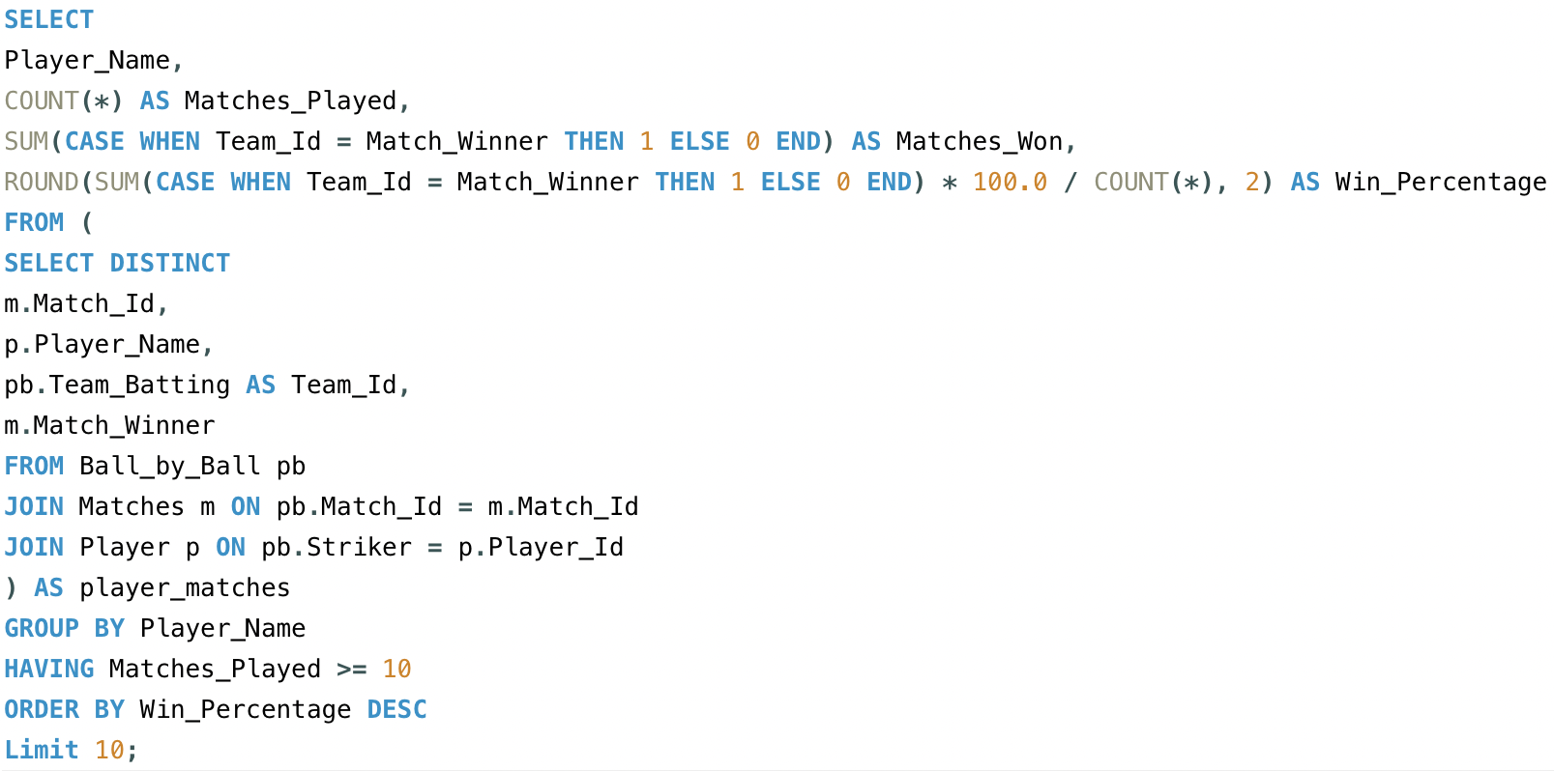

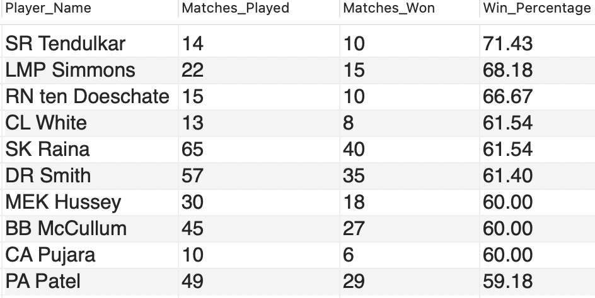

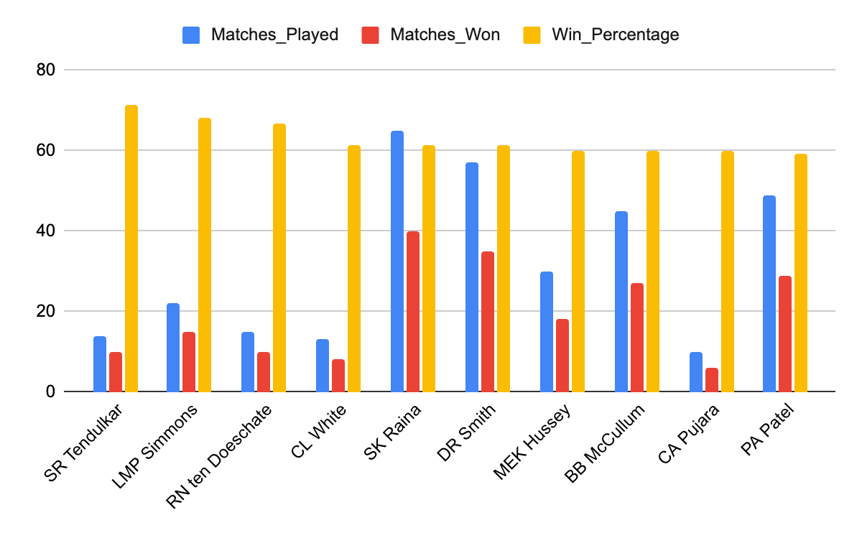

6. What would you suggest to RCB before going to the mega auction?

**Approach**: To suggest the right strategy for RCB ahead of the mega auction, I analyzed their past season performance using key metrics such as win/loss record, venue-based scoring patterns, bowling economy, batting consistency, player contributions, and squad balance. Based on this data-driven analysis, I identified RCB’s core weaknesses and outlined targeted recommendations for building a more balanced and competitive squad in the upcoming auction.

**Insights:**

The analysis of recent seasons shows the following performance trends for RCB:

* Runs conceded per match are increasing, with the highest in Season 9 (178.69).
* Wickets taken per match remain moderate, between 4.7 – 6.1 on average.
* Economy rate is rising, from 7.7 to 8.24, indicating bowlers are leaking more runs.

**Key Recommendations for RCB:**

* 1. **Retain Core Performers:** Keep consistent match-winners like Virat Kohli, AB de Villiers, Chris Gayle, and Yuzvendra Chahal to maintain team stability and leadership strength.
  2. **Strengthen the Bowling Attack:** Rising economy rate (8.24) indicates that RCB bowlers are giving away too many runs. So RCB must target:
* **Two aggressive powerplay bowlers** (swing bowlers)
* **One death-overs specialist**
* **One economical middle-overs spinner**
  1. **Improve Middle-Overs Control:** RCB should strengthen their middle-overs strategy by adding bowlers who can consistently build pressure through tight lines, variations, and quick wickets. Better control in overs 7–15 will reduce run flow, create more wicket-taking opportunities, and prevent opponents from setting or chasing big totals.
  2. **Secure a Backup Wicketkeeper:** Ensure a solid backup wicketkeeper to maintain flexibility in case of injuries or player unavailability**.**
  3. **Address Squad Balance:** Create a strong bench with reliable backup options across batting, bowling, and all-rounders — to avoid performance drops during long tournaments.
  4. **Emphasize the Need for All-Rounders:** RCB should invest in 2–3 multi-dimensional all-rounders who can support middle-over bowling and strengthen lower-order batting. This improves flexibility in team selection**.**
  5. **Venue-Specific Recruitment:** Since Chinnaswamy is a batting-friendly ground with small boundaries, RCB must prioritize:
     + Bowlers with tight economic control
     + Spinners who bowl flat and quick
     + Death-over specialists with slower variations

This ensures the squad is suited to their home conditions.

* 1. **Match Strategy and Data-Driven Decision Making**: Use player analytics and past performance trends to make smart, value-for-money buys rather than going only for names.

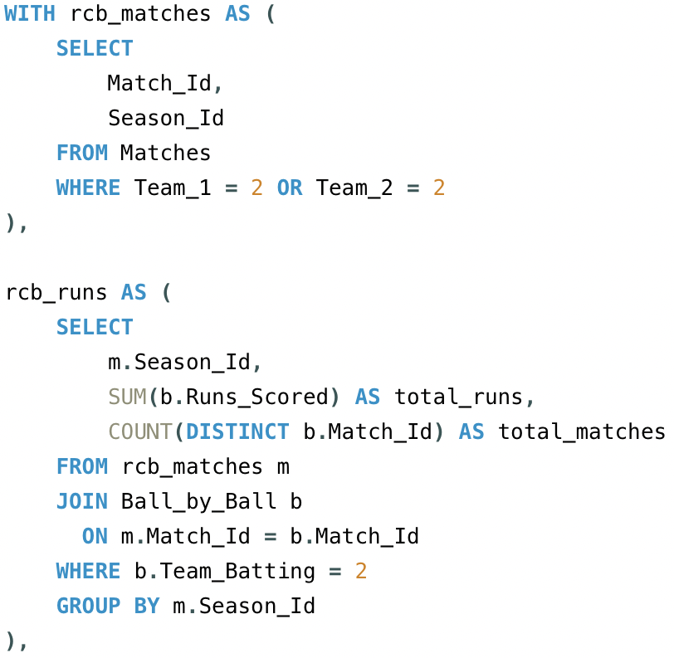

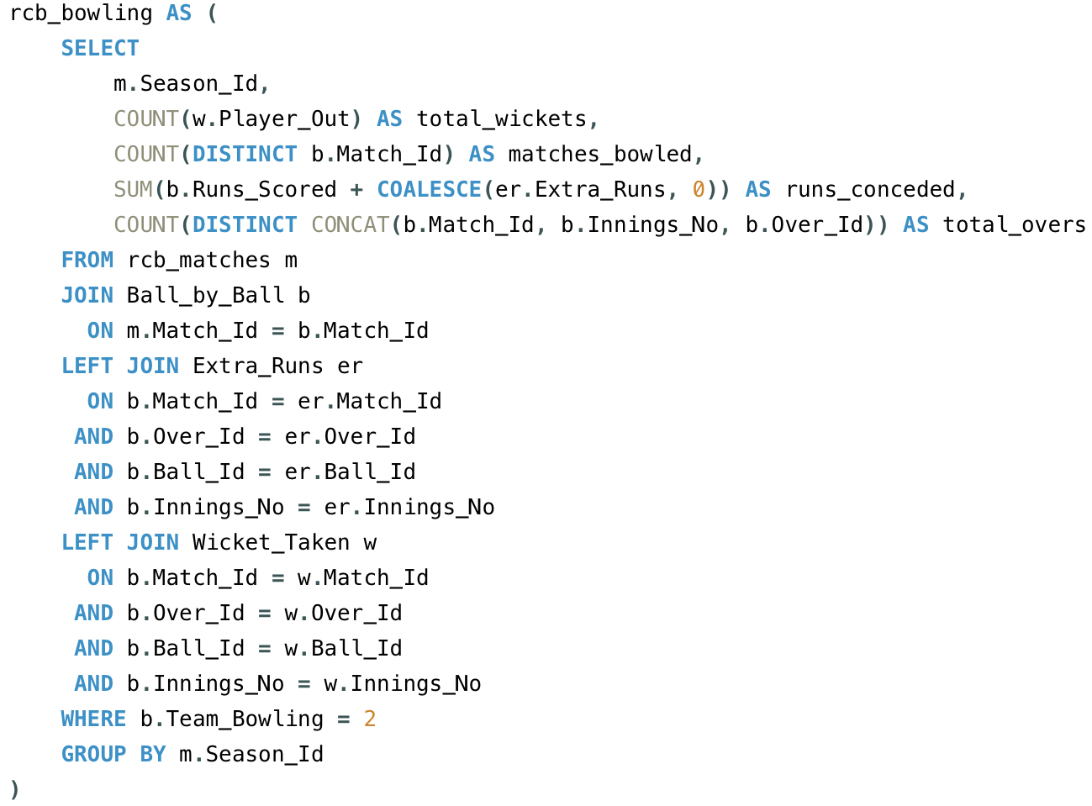

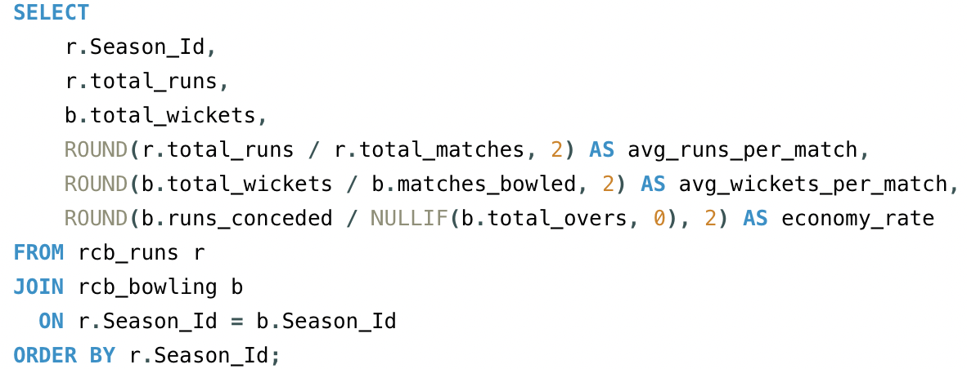

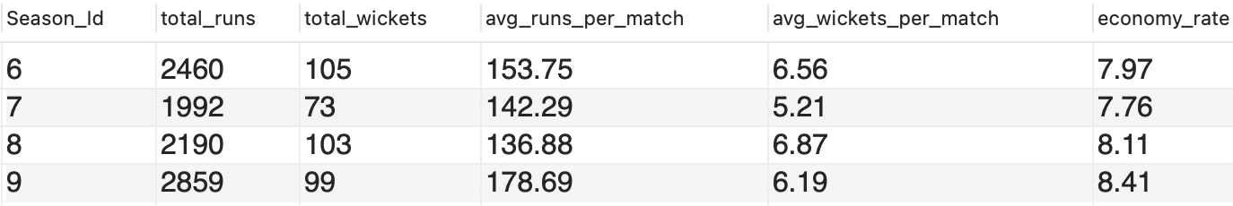

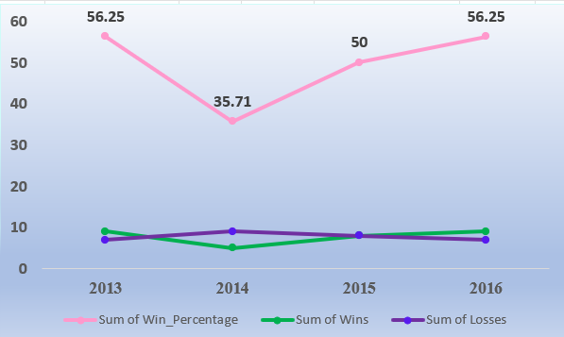

7. What do you think could be the factors contributing to the high-scoring matches and the impact on viewership and team strategies

**Ans.** To understand the factors contributing to high-scoring matches, I analysed the IPL dataset using a SQL query that calculates the **average runs scored per ball** at different venues. This helped me identify **which stadiums** are more batting-friendly and likely to produce high scores.

**Query Approach:**

* This query joins the Ball_by_ball,matches and venue tables.
* Calculate the average number of runs scored per ball at each venue.
* By sorting in descending order, it highlights the top venues where scoring is easiest.

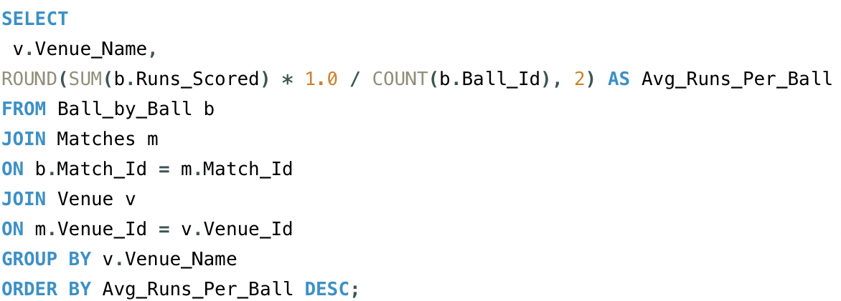

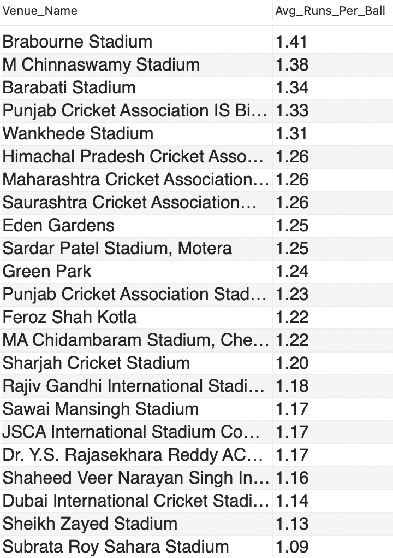

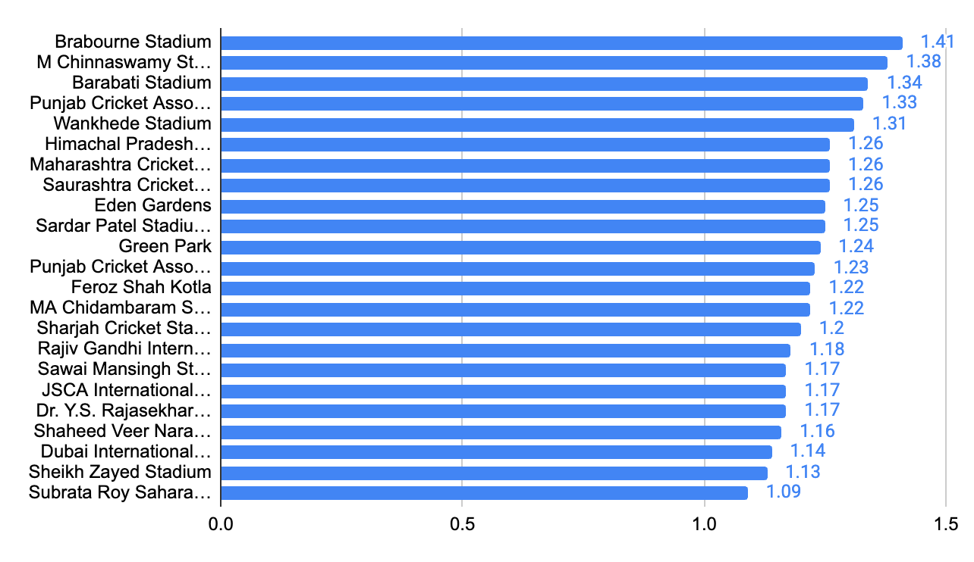

**Insights from the Query:**

1. **Certain venues consistently have higher scoring rates.**
   1. These are usually grounds with **short boundaries and flat pitches**.
   2. Bowlers struggle more, while batters score faster.
2. **Teams playing at these venues tend to score 180+ regularly.**
   1. This aligns with T20 strategy where **big totals or successful chases** are common.

**Impact on Viewership:**

* **High-scoring matches are more thrilling**, which boosts live viewership and online engagement.
* Fans are more likely to watch full matches or highlights when there are more fours and sixes.
* Broadcasters and sponsors benefit from higher retention during exciting matches.

**Impact on Team Strategies:**

* **Player Selection:** Teams pick **aggressive batsmen** and **death-over finishers** for high-scoring venues.
* **Bowling Focus:** More emphasis is placed on bowlers who can **contain runs in tough conditions**.
* **Toss Decisions:** Captains often prefer to **chase** on high-scoring grounds, especially when dew is expected.

**Conclusion:**

By using a simple SQL query to analyse average runs per ball at each venue, I concluded that **pitch and venue conditions are major factors** in high-scoring matches. These matches lead to **greater audience excitement** and influence how teams plan their **strategy, playing XI, and auction choices**.

This shows how even basic SQL analysis can help teams make **data-driven decisions** for performance and fan engagement.

8. Analyze the impact of home-ground advantage on team performance and identify strategies to maximize this advantage for RCB.

**Ans.** To analyse the impact of home-ground advantage, I used the IPL dataset to compare how teams performed at their home venues versus other venues. Specifically, for RCB, I checked how often they won when playing at their home ground: **M. Chinnaswamy Stadium, Bangalore.**

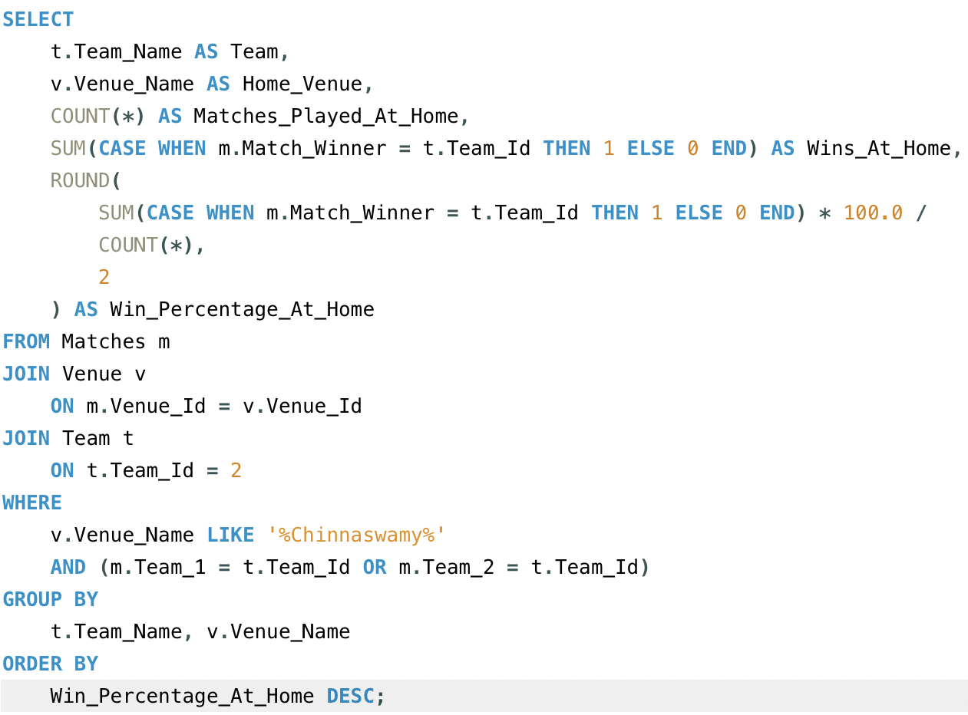



**9.** Come up with a visual and analytical analysis of the RCB's past season's performance and potential reasons for them not winning a trophy.

The following analysis examines Royal Challengers Bangalore’s performance across IPL seasons, focusing on their match outcomes, win percentage, and key factors that may have impacted their ability to win a trophy. Below are the tables required for the analysis.

**Required Tables**

* **matches:** For match details like winner, season, and teams.
* **team:** To identify RCB in matches.
* **season:** For season-wise performance data (year).

**Approach**

* **Filter RCB Matches:** Extract all matches involving RCB.
* **Calculate Wins and Losses:** For each season, count matches played, won, and lost.
* **Win Percentage Calculation:** Calculate win percentage by season.
* **Season Mapping:** Join the performance data with the season table to display season-wise results.

**Insights**

* **Inconsistent Performance:** RCB’s performance fluctuates, with strong seasons followed by weaker ones.
* **Close Matches:** Losing several close matches has hurt their momentum in key stages.
* **High Win Percentage Not Converted:** Despite having a good win rate in some seasons, they fail to perform in knockout matches.

**Potential Reasons for Not Winning a Trophy**

* **Team Imbalance:** Heavy reliance on top-order batsmen, while middle-order and bowlers lack consistency.
* **Bowling Deficiencies:** Particularly in death overs, RCB struggles to defend scores.
* **Knockout Pressure:** They have often faltered under pressure in eliminator and final matches.
* **Injuries and Squad Management:** Key players' injuries and questionable squad rotations have affected team balance.

**Recommendations**

* **Strengthen Bowling Unit:** Focus on improving death-over specialists.
* **Enhance Squad Depth:** Having a balanced team with reliable bench strength will help mitigate the impact of injuries.
* **Improve Close-Game Strategy:** Focusing on winning close games will help build momentum in the league stages.

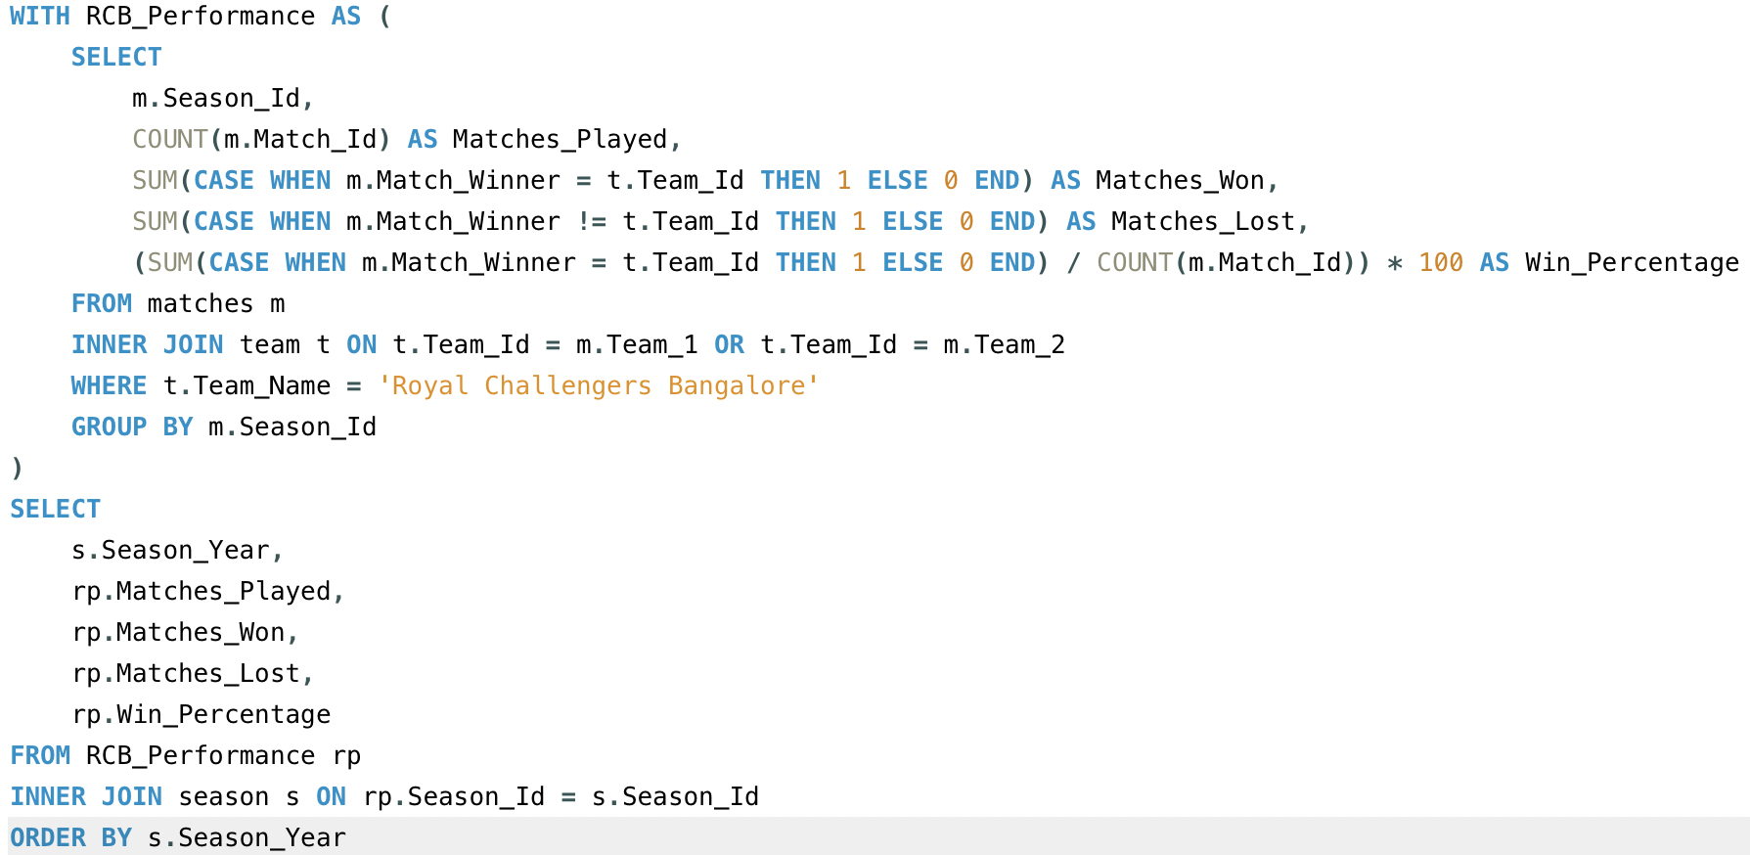

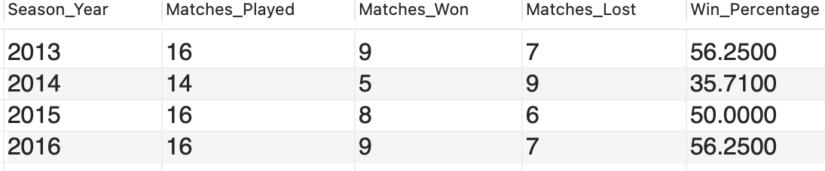

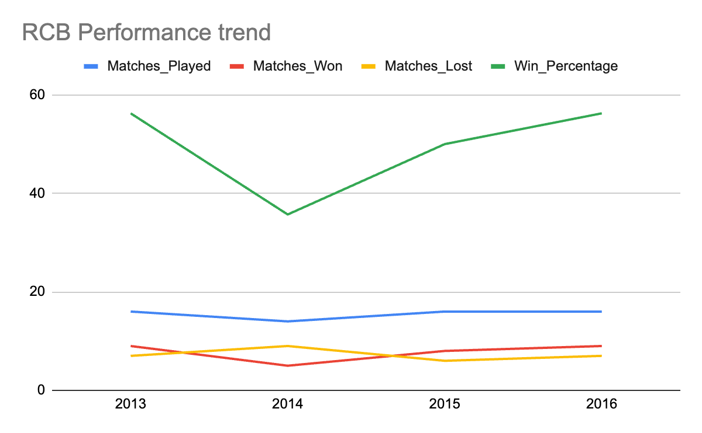

Q10. How would you approach this problem, if the objective and subjective questions weren't given?

**Ans.** If the questions were not predefined, I would start by understanding the dataset and then use a data-driven exploration approach combining SQL analysis and visualization.

**Step-by-step Approach:**

**Step 1: Understand the Dataset**

* Start by checking all the tables available (like Matches, Ball_by_Ball, Player, Team, Venue, etc.) and try to understand what each table contains and how they are related.
* Check relationships (foreign keys like Match_Id, Team_Id, Player_Id, etc.).
* Some basic things I would explore:
* Which columns store match results?
* How runs and wickets are tracked?
* How players are linked to teams?

**Step 2: Decide on Key Areas to Analyze**

* + **Team Performance Analysis**
    - Total matches played, wins, losses, win percentage
    - Best and worst seasons by win percentage
    - Home vs away performance comparison
* **Batting Performance**
  + - Total runs by each player
    - Strike rate, average, and consistency
    - Best partnerships and top scorers
* **Bowling Performance**
  + - Total wickets per player
    - Economy rate (runs per over)
    - Most impactful bowlers by match wins
* **Venue Impact**
  + - High-scoring grounds
    - Toss decision success (bat/field first)
    - RCB’s performance at home vs away grounds

**Step 3: Write SQL Queries to Explore the Data**

Once I know what I want to study, I would write SQL queries to extract meaningful insights.

For example:

* To check top batsmen: group by player and sum runs
* To check bowling economy: total runs given / total balls bowled × 6
* To see team win % by season: count wins per season and divide by total matches

**Step 4: Visualize and Interpret**

After generating insights from SQL, I would create visuals (in Excel or Power BI) to present:

* Bar charts for top scorers
* Line charts for team progress season-wise
* Pie charts for win/loss ratio

**Conclusion:**

Even without predefined questions, I would approach this IPL data project like a real data analyst:

* Understand the data
* Decide what KPIs to measure
* Ask meaningful questions
* Write SQL queries to answer them
* Visualize results clearly

11. In the "Match" table, some entries in the "Opponent_Team" column are incorrectly spelled as "Delhi_Capitals" instead of "Delhi_Daredevils". Write an SQL query to replace all occurrences of "Delhi_Capitals" with "Delhi_Daredevils".

**Ans.** There is no column named Opponent_Team in the matches table. If such a column were present, the query to replace "Delhi_Capitals" with "Delhi_Daredevils" would look like this:

**UPDATE matches**

**SET Opponent_Team = 'Delhi_Daredevils'**

**WHERE Opponent_Team = 'Delhi_Capitals';**

This query directly updates the Opponent_Team column, replacing all occurrences of "Delhi_Capitals" with "Delhi_Daredevils".